# CASE MANAGEMENT

# Date: 11/04/2016

## Time: 10:28am: Start of Investigation

* *Opened Encase*
* *Started a new Case*
  + *Case Name: 2016_04_Sam_Malone*
  + *Case Number: 2016 04 Sam Malone*
  + *Bade-Adebowale Kehinde K.*
  + *Investigation of Mr Sam Malone's Image for illegal trade of weapon and illegal money transfer*

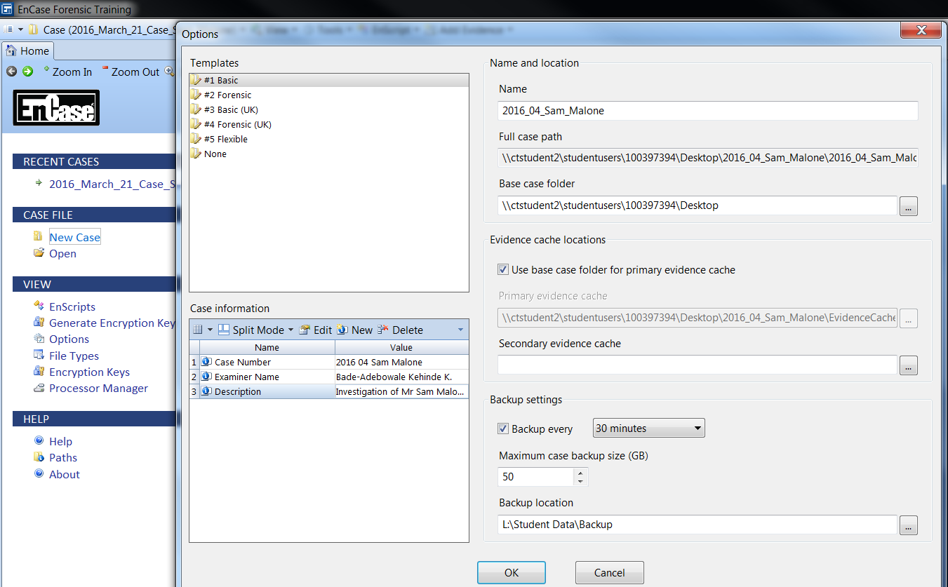

Image-

## Time: 10: 39am: Evidence is “Write Protected”

* *Confirmed that the evidence is write protected*
* *Added the evidence file*
* *Path: S:\Common Area\Forensics - All Years\Evidence Files\Malone*

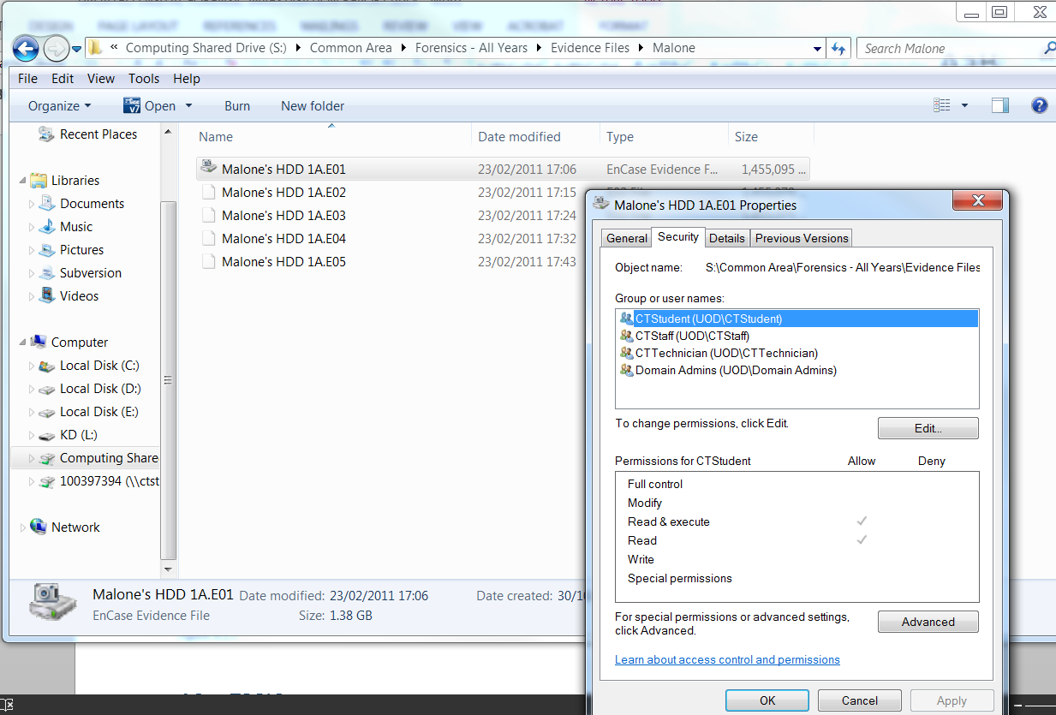

Image-

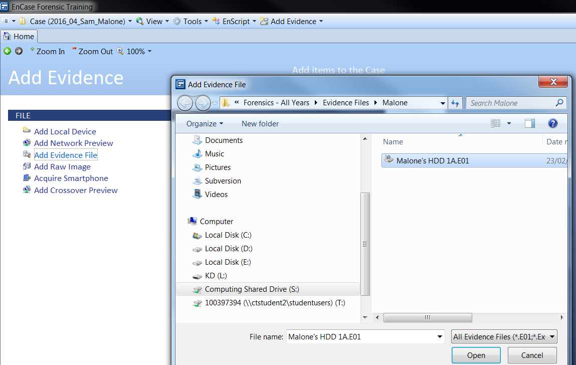

Image-

## Time: 10:42am: Verification of Evidence

* *Verification process began*

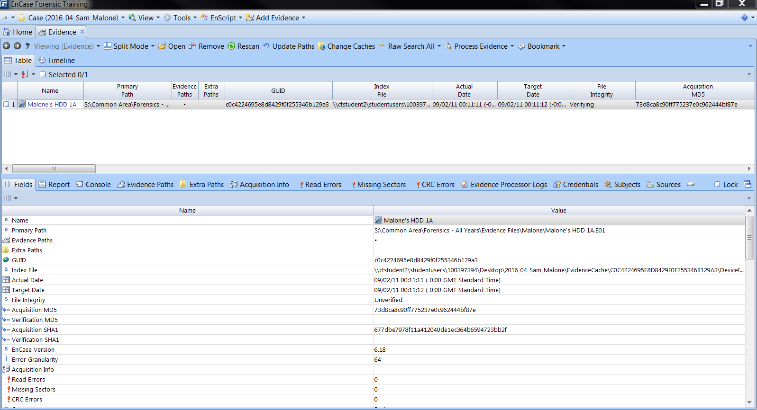

Image-

## Time: 10:49am: Evidence encrypted

* *Opened Evidence*
* *Discovered evidence was encrypted*
* *Did a raw search for the BitLocker recovery password*

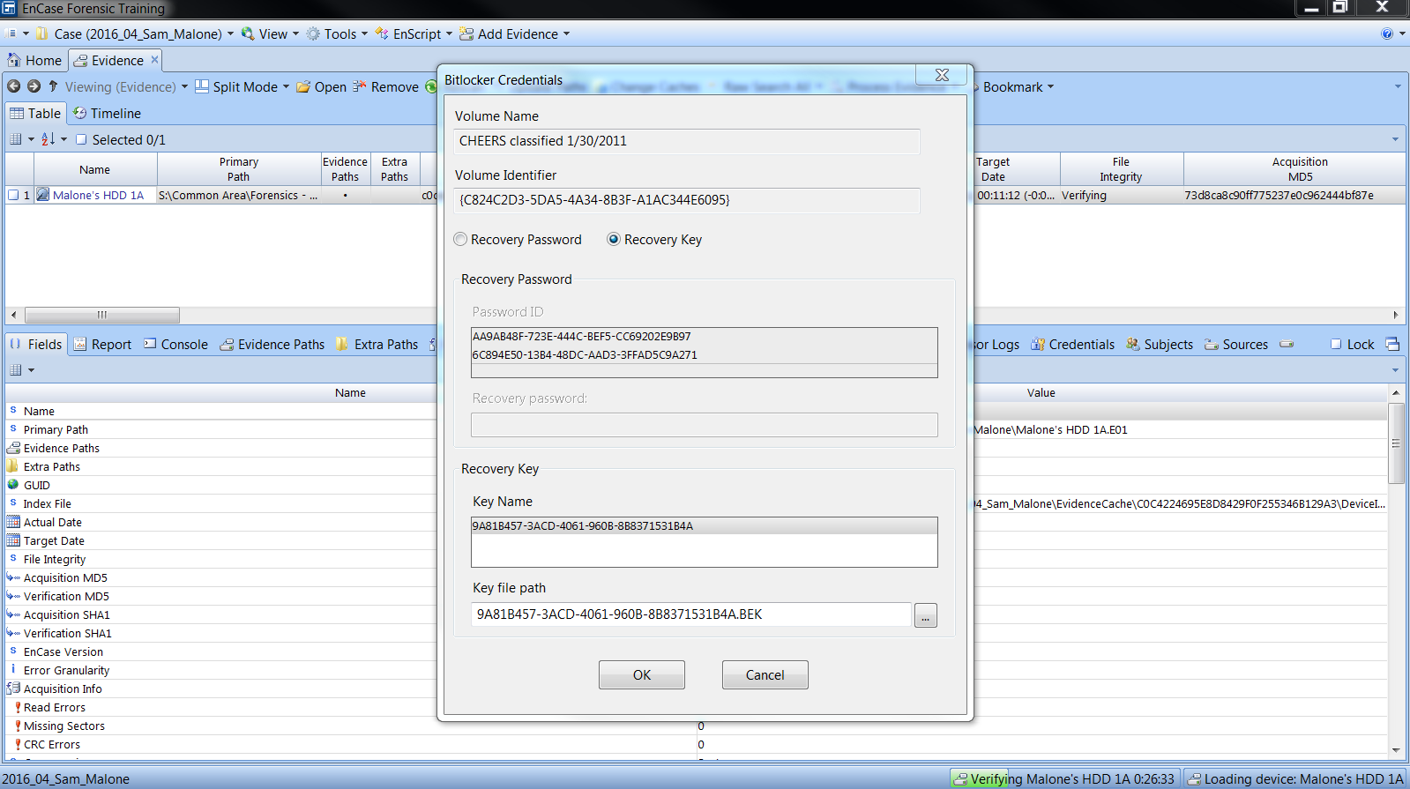

Image-

## Time: 10:54am: Disk Decryption (BitLocker)

* *Found the Bitlocker recovery password*
* *Entered it to decrypt the disk*

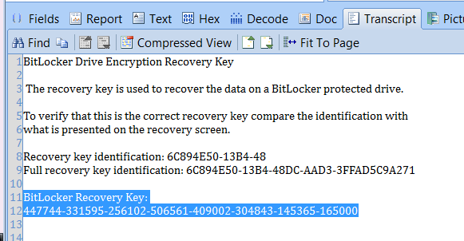

Image-

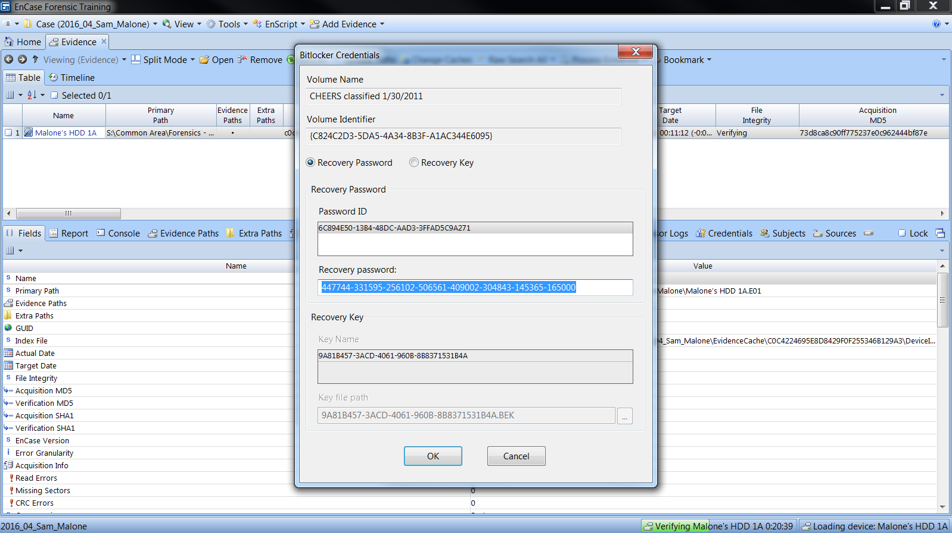

Image-

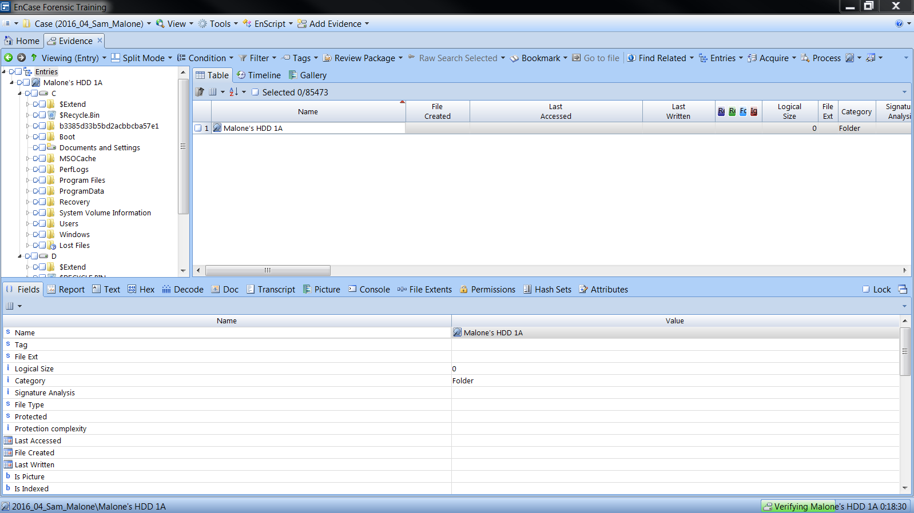

Image-

## Time: 11:01am: Time Zone Configuration

* *Checked the time-zone of the image on acquisition*
* *Path: C/Windows/System32/config/SYSTEM*
* *SYSTEM (Highlighted) => Entries => View File Structure*
* *The time-zone was Pacific Standard Time (PST)*
* *Changed Encase’s time-zone to PST*

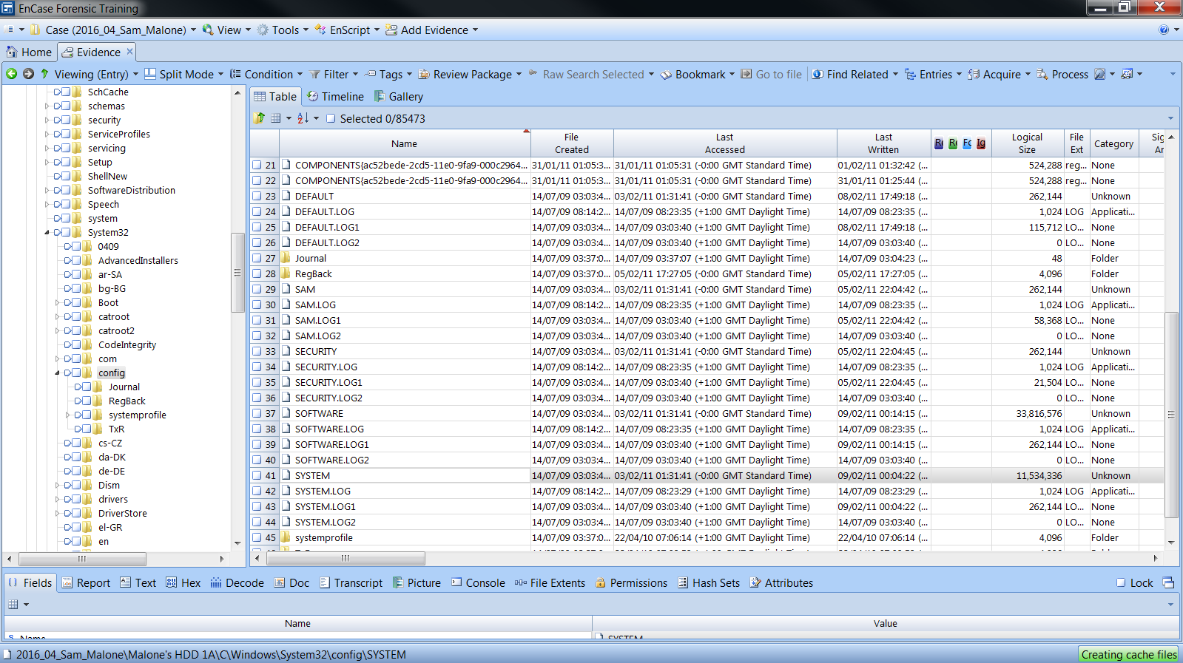

Image-

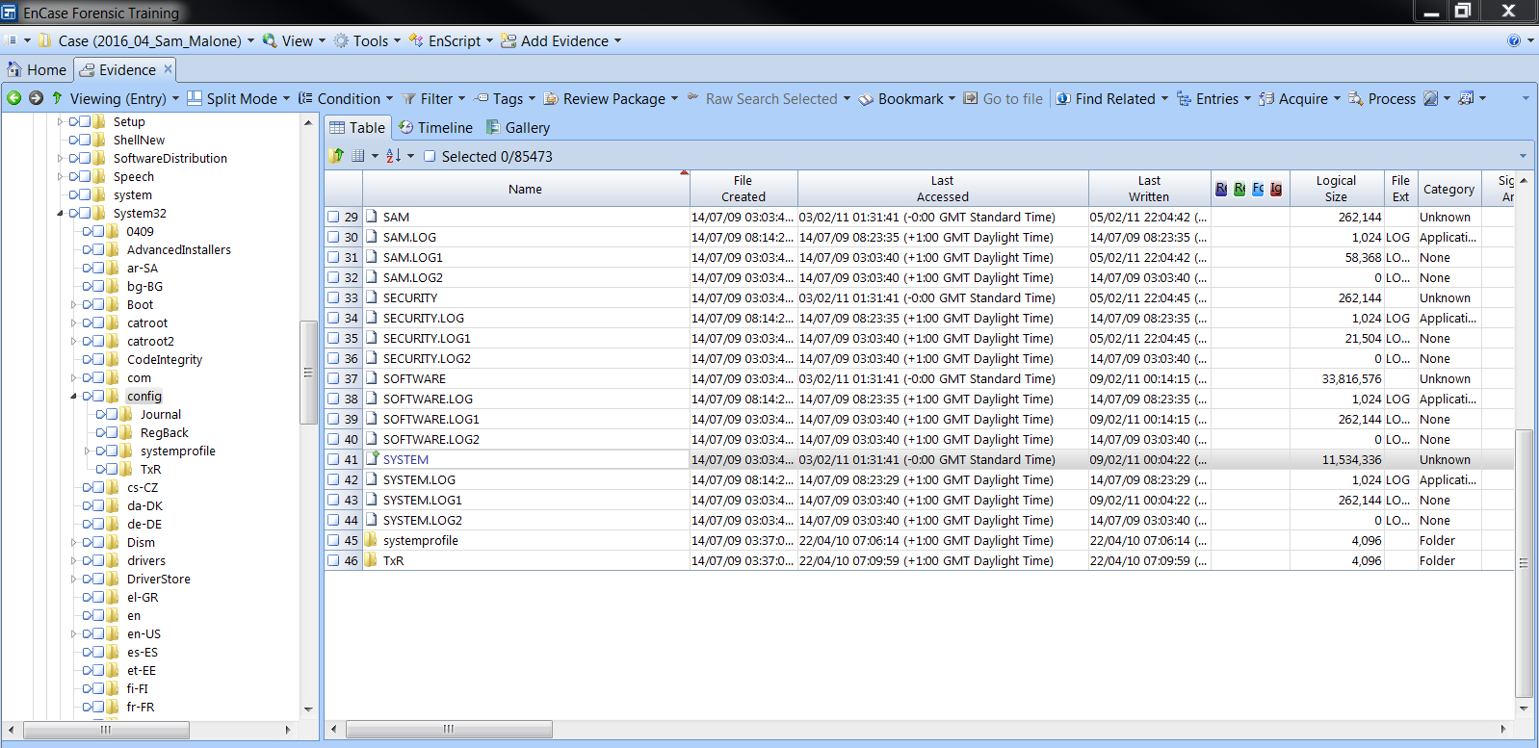

Image-

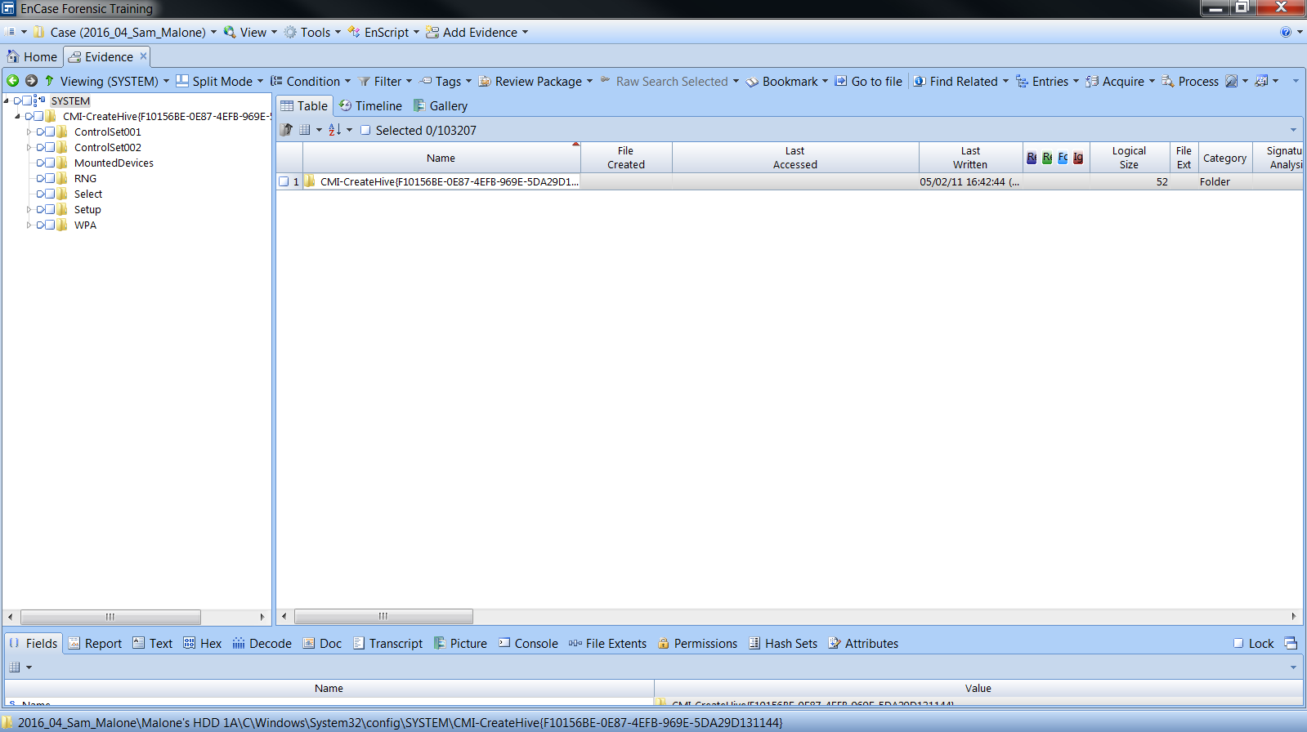

Image-

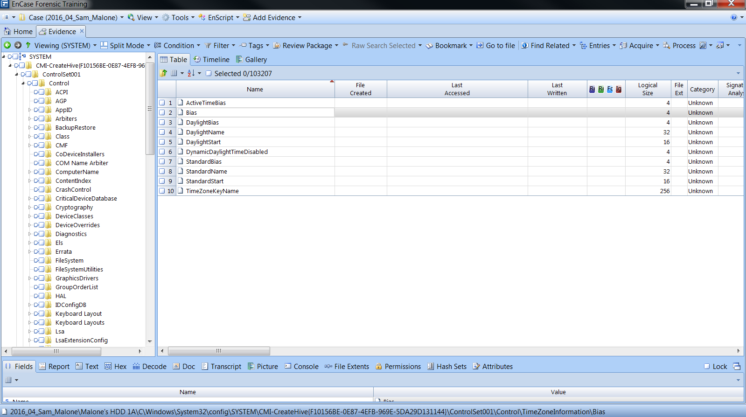

Image-

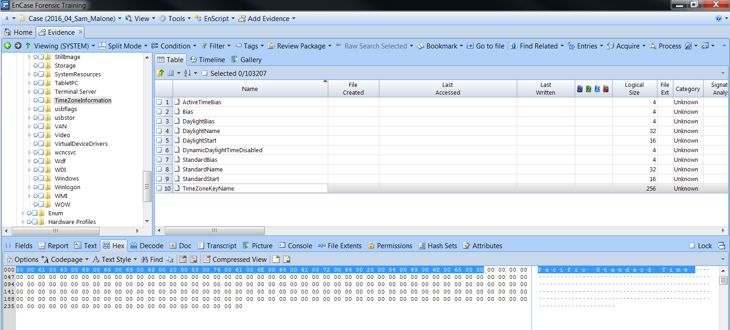

Image-

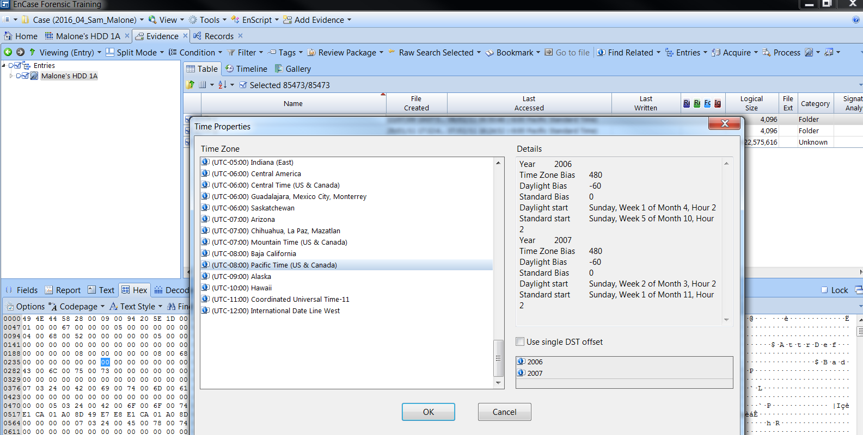

Image-

## Time: 11:15am: End of Evidence Verification

* *Verification ended*
* *Confirmed that acquisition MD5 Hash and verification MD5 Hash are the same*
* *Confirmed that acquisition SHA1 Hash and verification SHA1 Hash are the same*

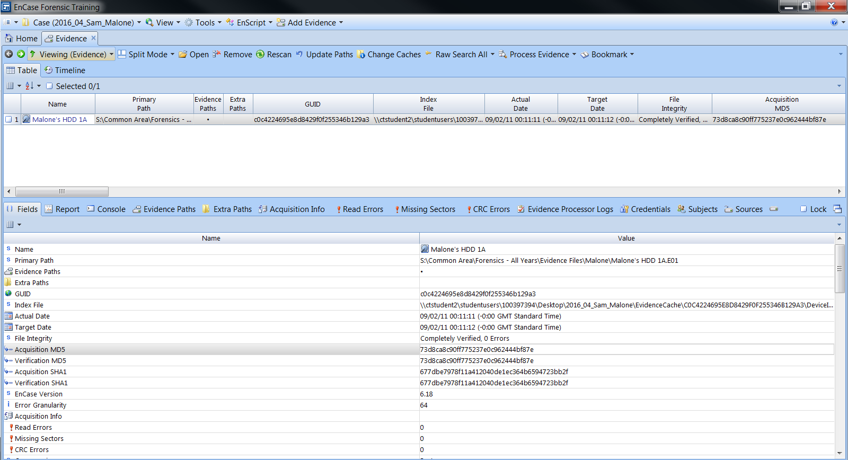

Image-

## Time: 11:20am: Disk Analysis

* *Checked for deleted partitions*
* *Found a deleted partition*
* *Retrieved deleted partition*

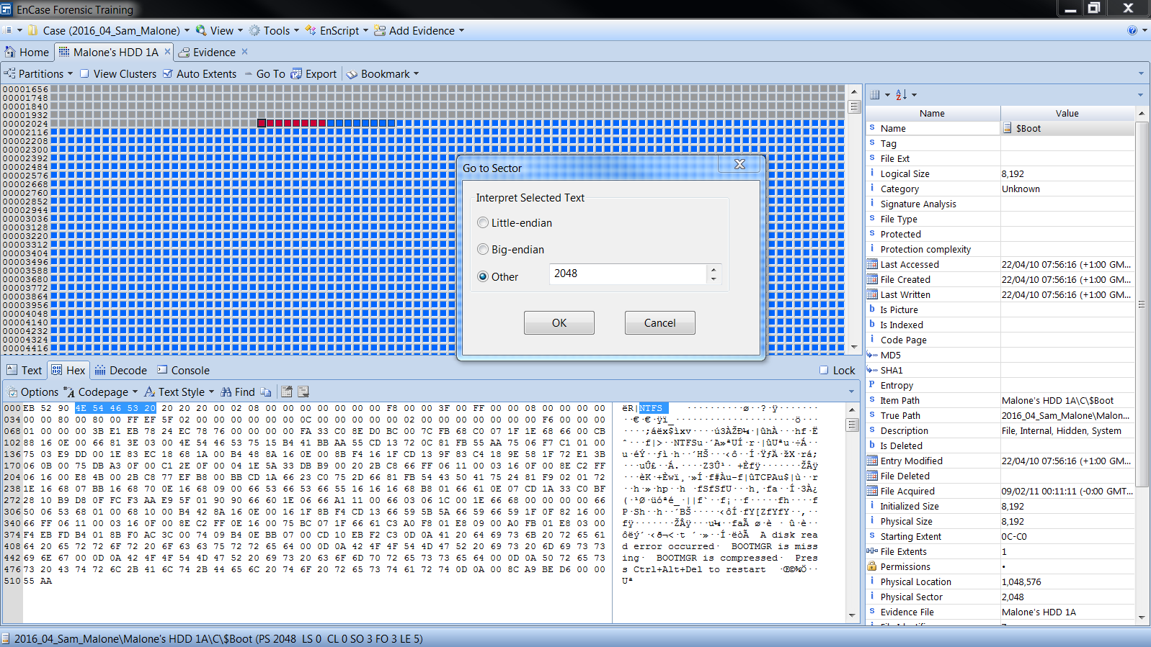

Image-

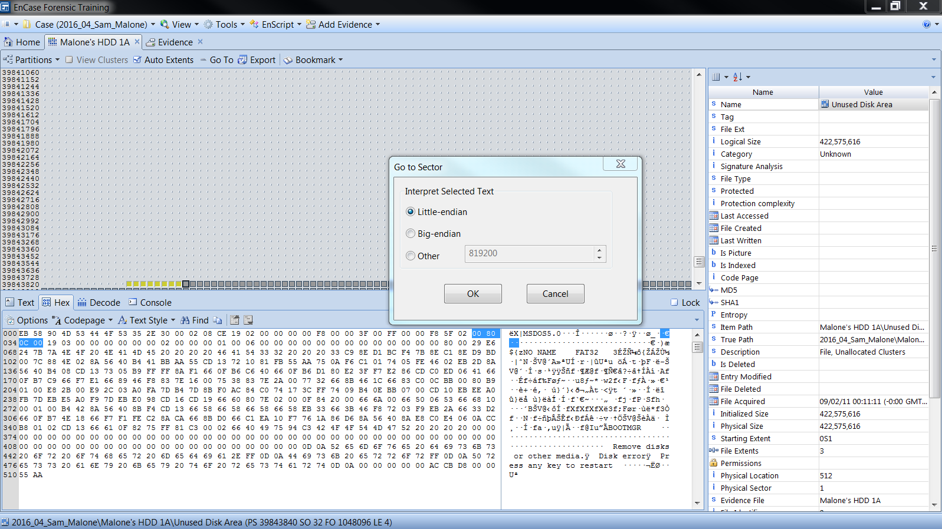

Image- 16

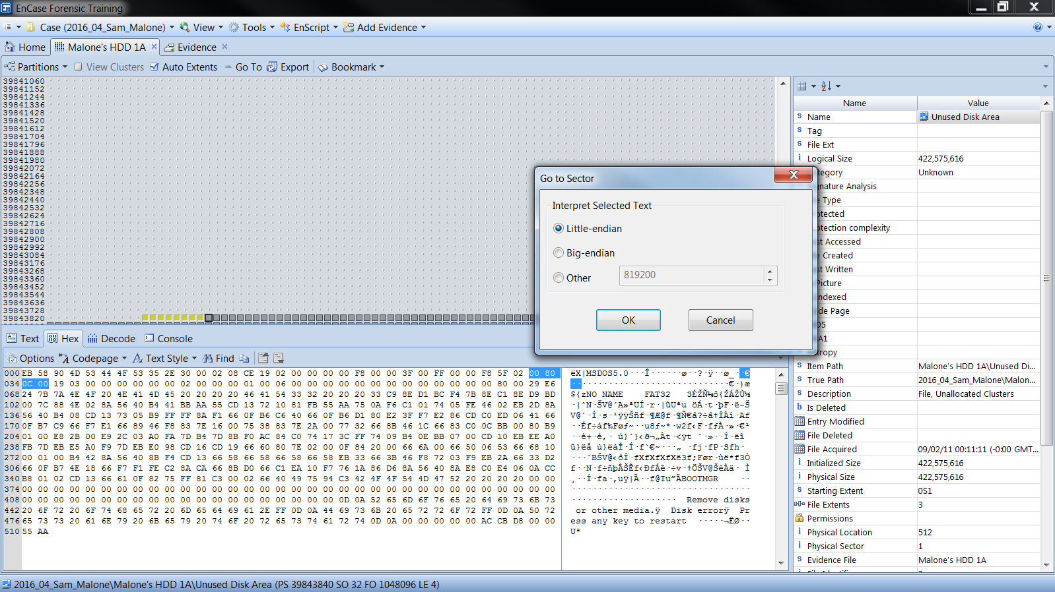

Image- 17

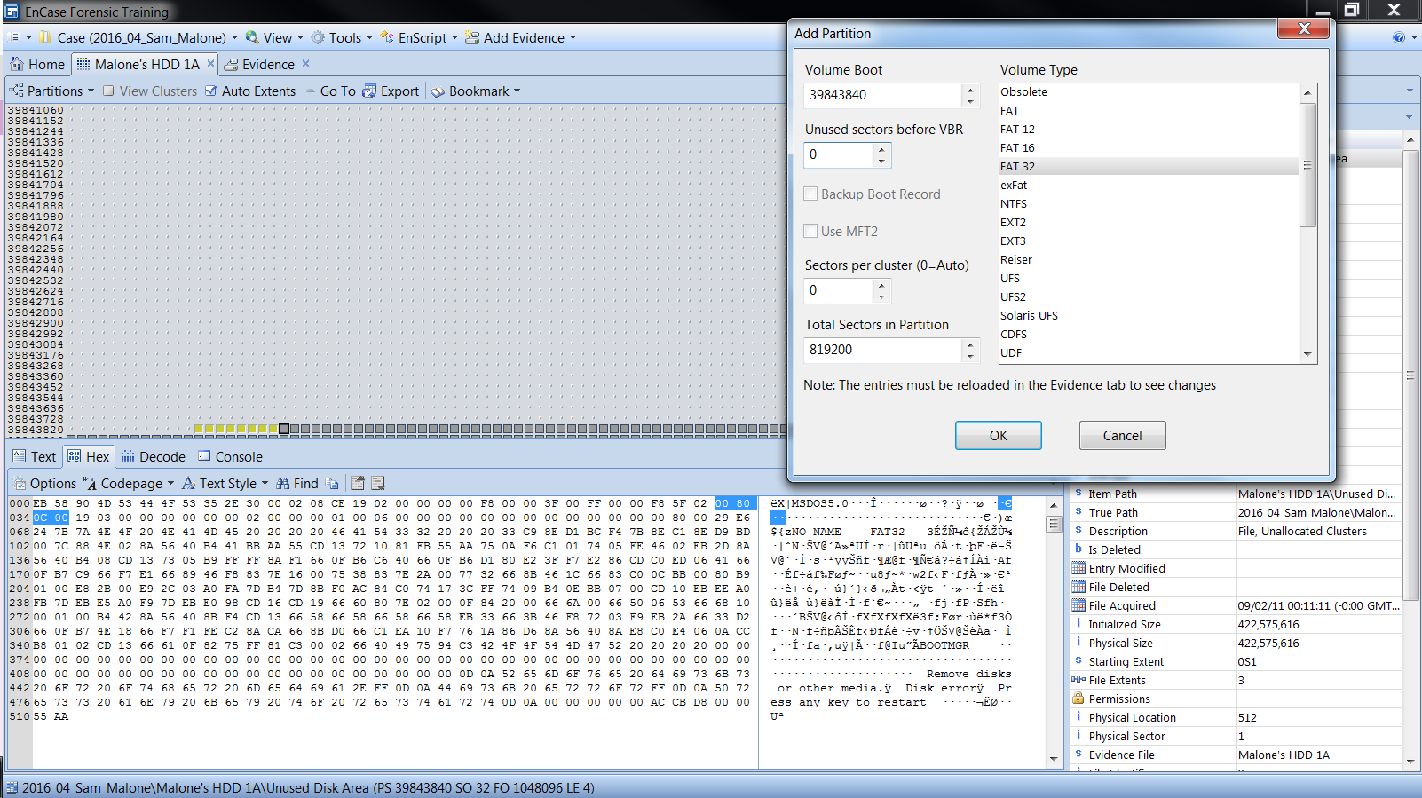

Image-

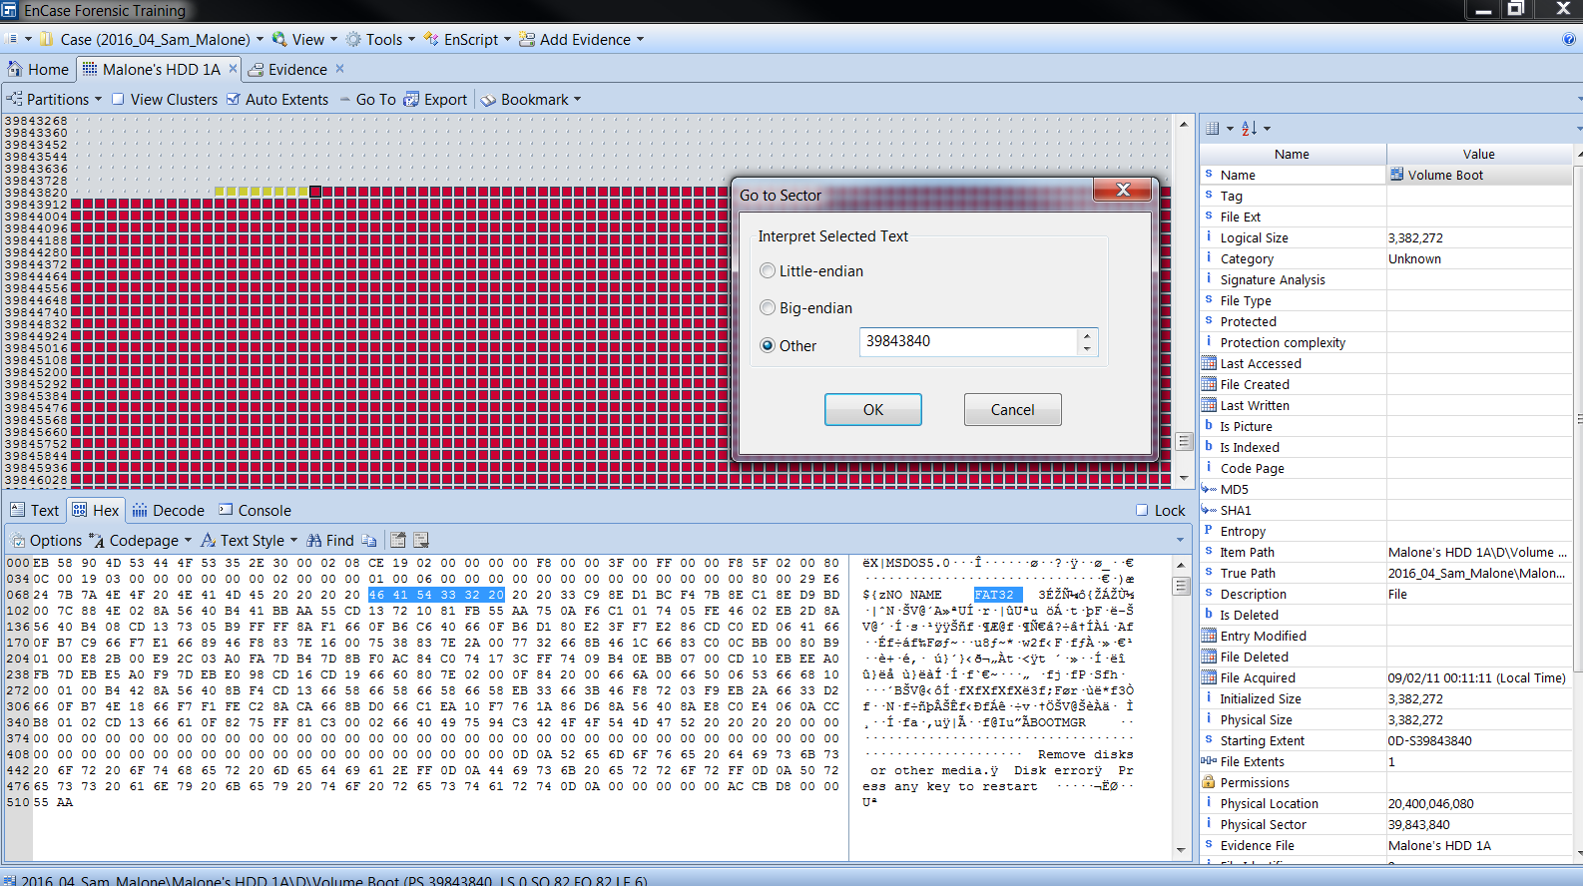

Image-

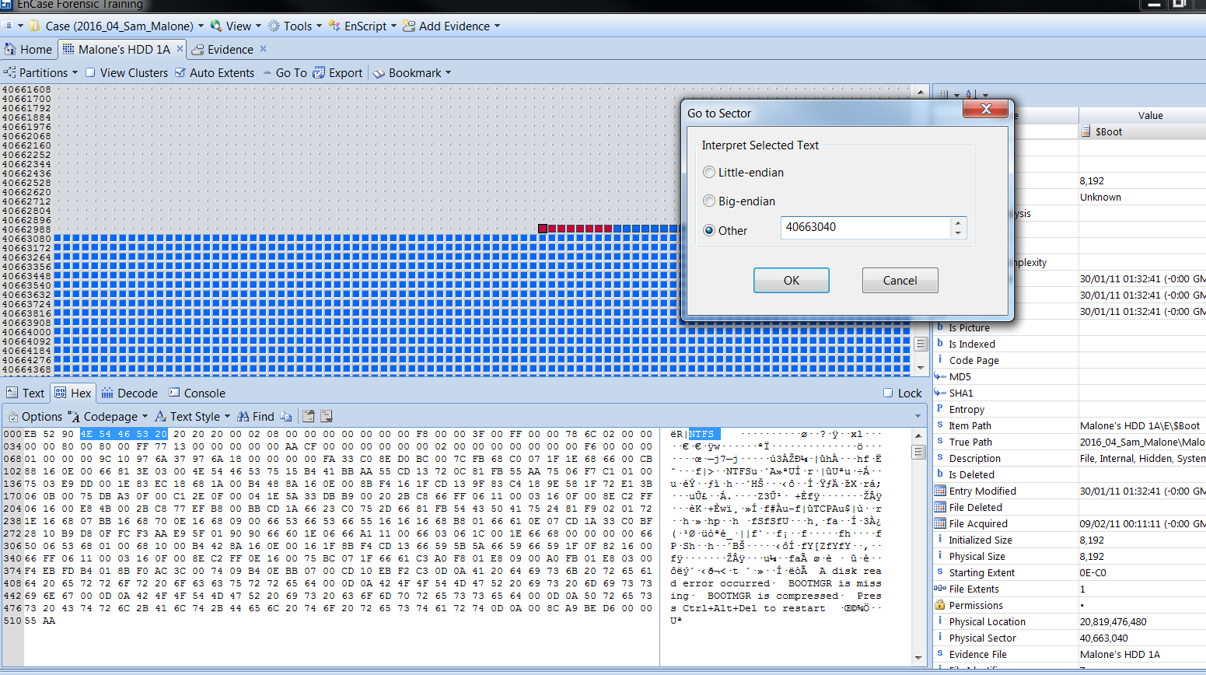

Image-

## Time: 12:19pm: Starting Evidence Processing

* Processed evidence

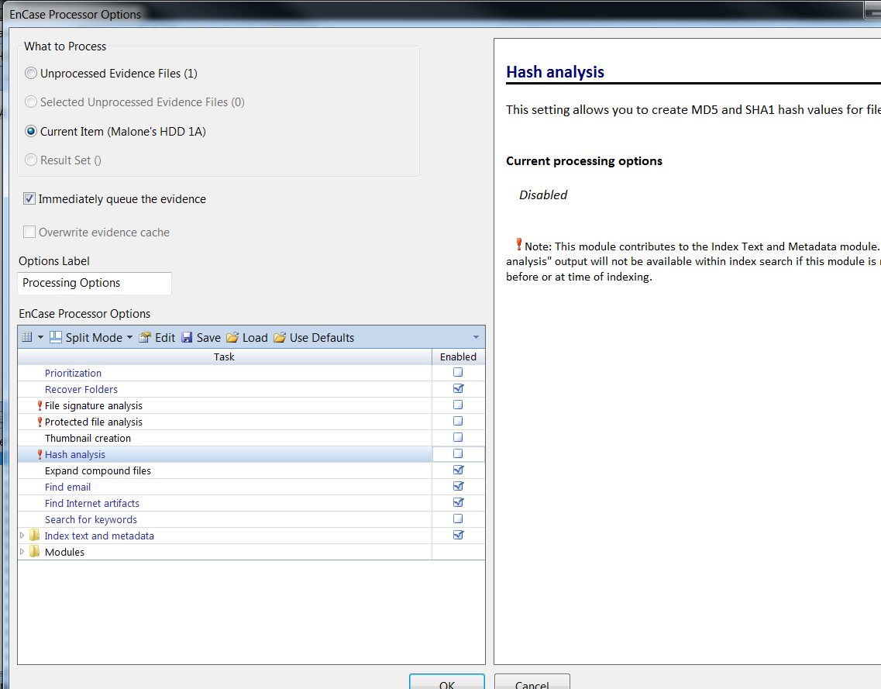

Image-

## Time: 12:48pm: Processed Evidence (No Result)

* Processed evidence brought out no result
* Restart the Evidence Processing

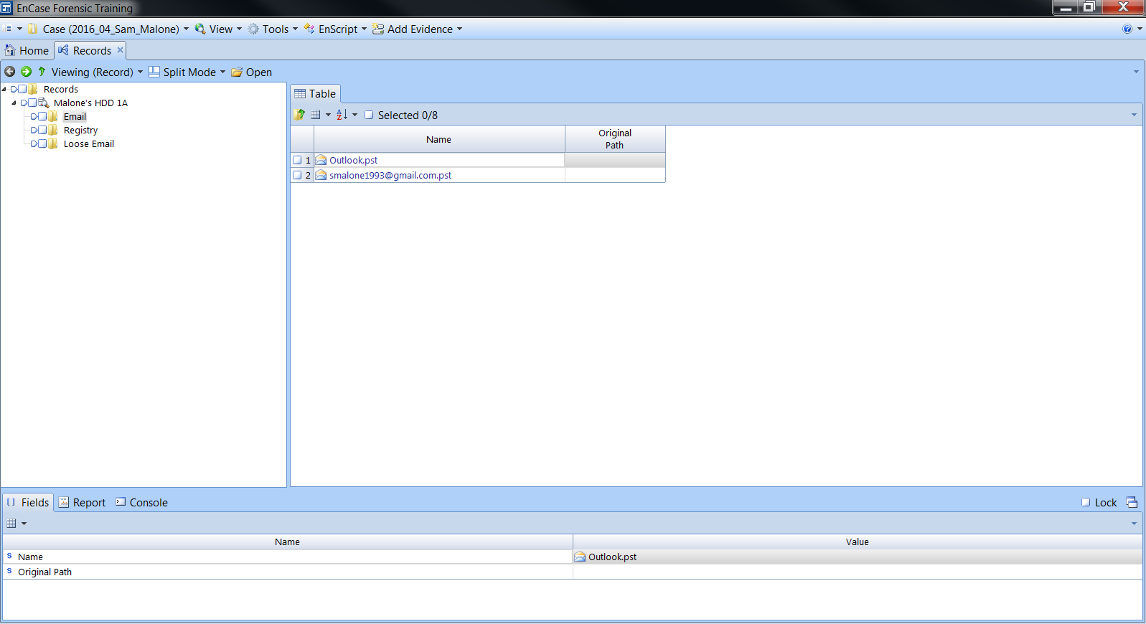

Image-

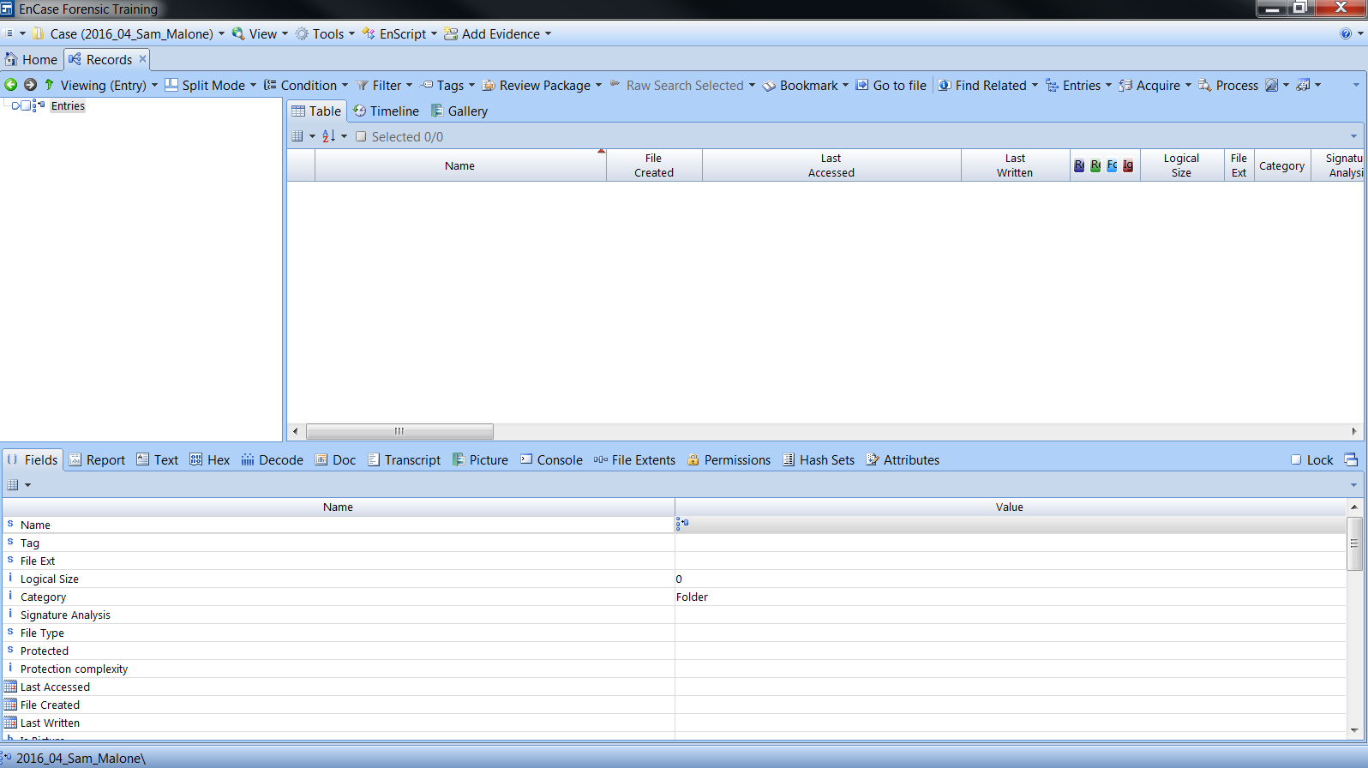

Image-

## Time: 12:59pm: Restarted System

* Restarted my Computer
* System Restarted

## Time: 01:10pm: Restarted Process again

* Started the process again

## Time: 2:10pm Opened Internet Artefact

* Visits to [www.truecrypt.org](http://www.truecrypt.org) 2
* Visited [www.loyalkng.com](http://www.loyalkng.com) and viewed a picture named “nucleat-explosion.jpg”
* Weapon Purchase Order
* Picture captioned “nuclear-explosion.jpg”
* Visited [www.t0.gstatic.com](http://www.t0.gstatic.com) and viewed pictures of several explosions

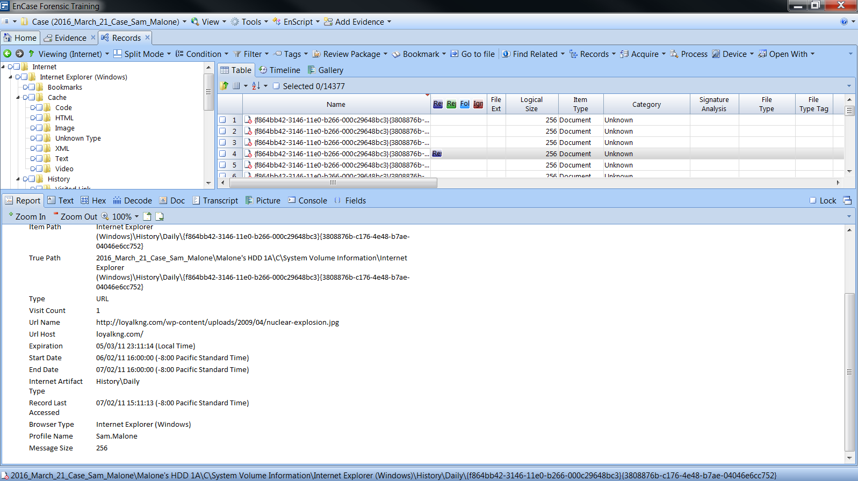

Image-

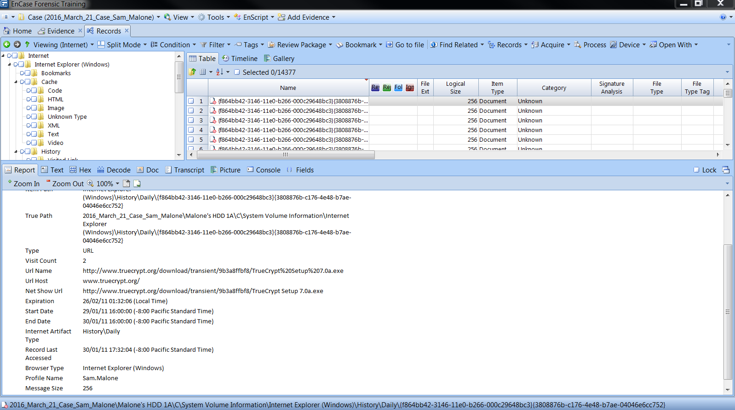

Image-

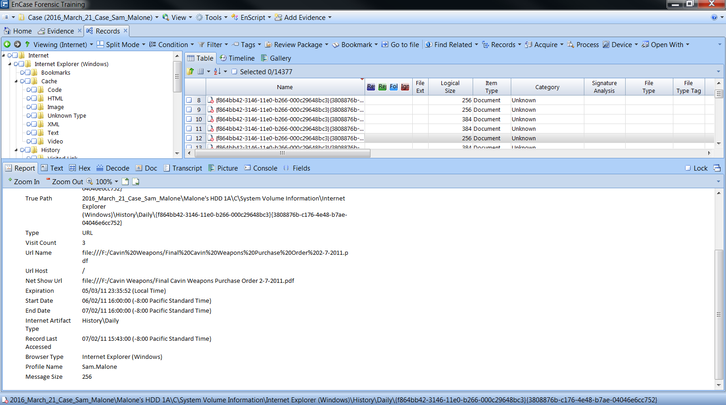

Image-

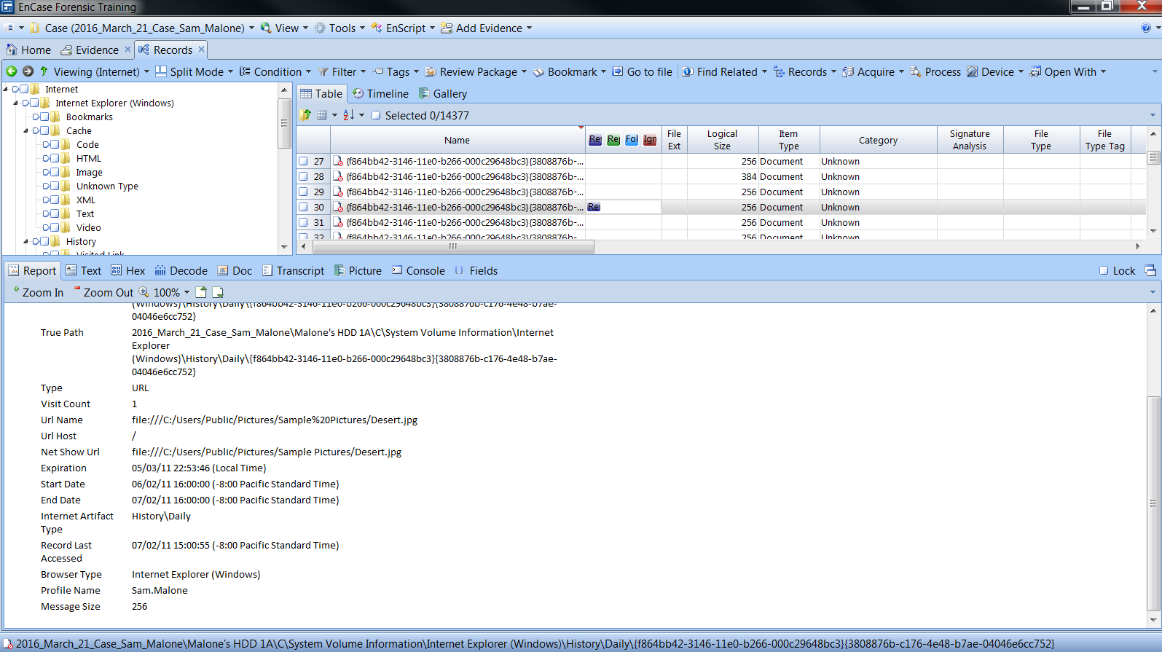

Image-

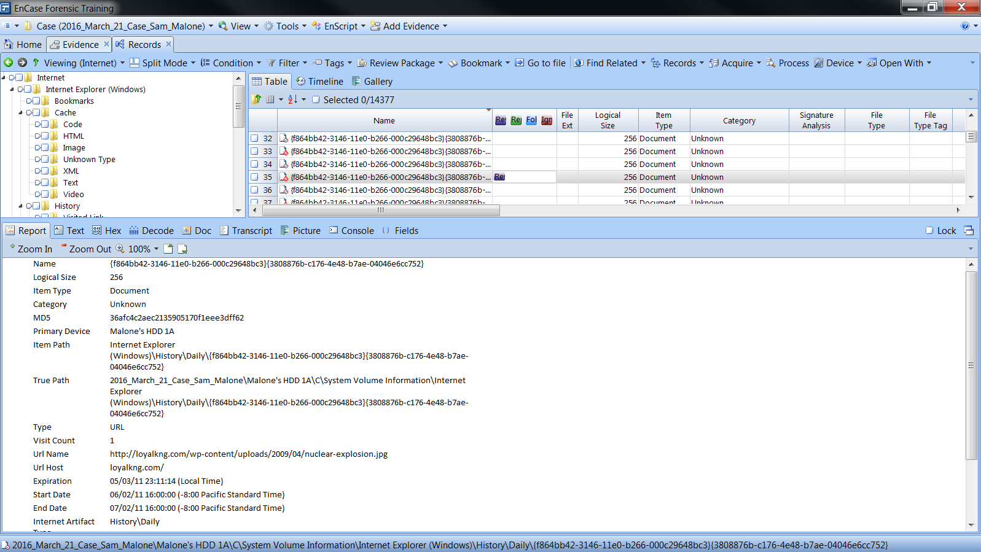

Image-

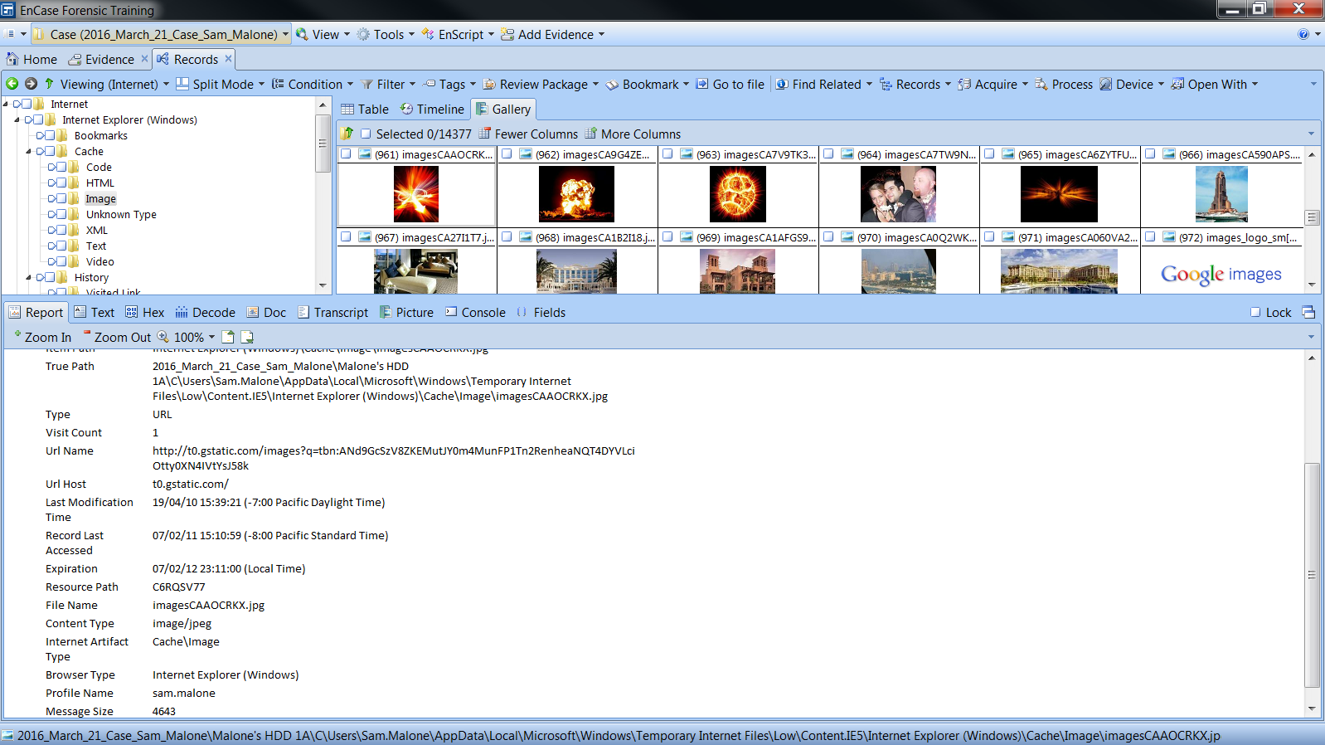

Image-

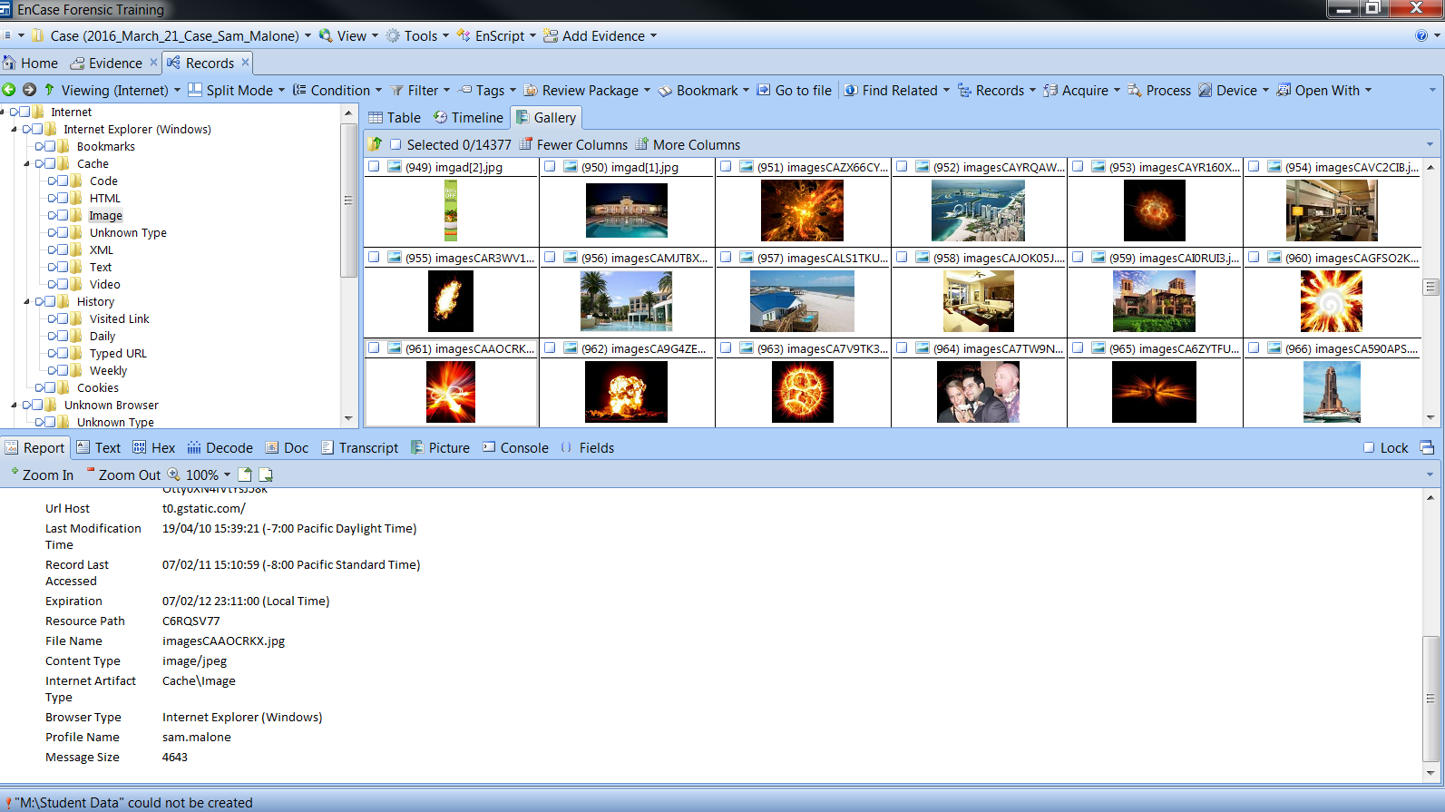

Image-

## Time 3:38pm: Begin Email Investigation

* *Mr. Cliff Cavin Contacts Mr Sam Malone*
* *Mr. Cliff Cavin Sends Mr Sam Malone a Proposal and an image of a drone tested in South America and the Middle East*
* *Mr. Cliff Cavin sent Mr. Sam Malone a presentation*
* *The Purchase Order*
* *Mr. Cliff Cavin tells Mr. Sam Malone to download TrueCrypt*
* *Mr Sam Malone Pays $22,950,000,000.00 into Mr. Cliff’s Account*

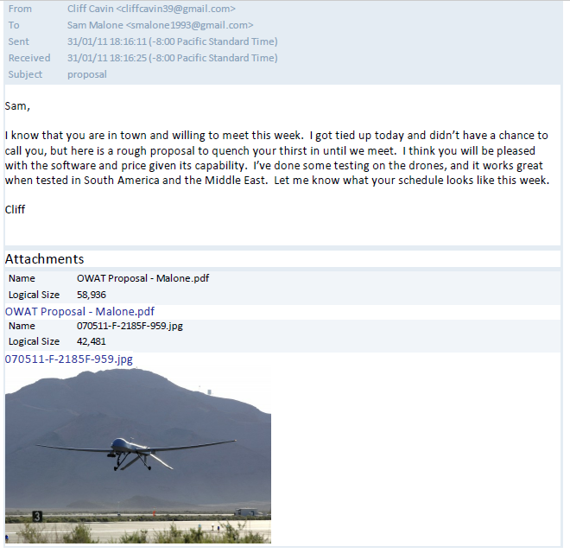

Image-

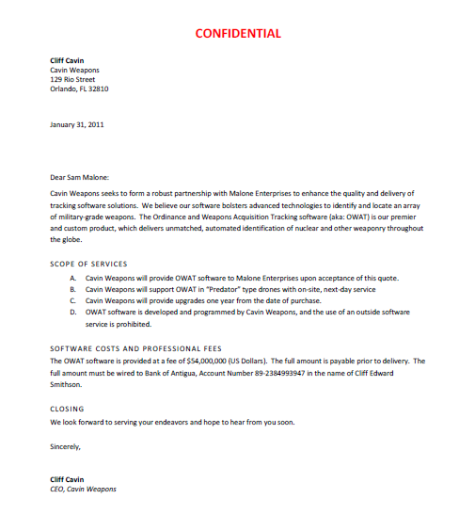

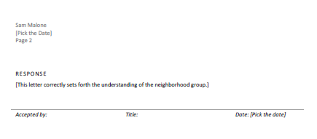

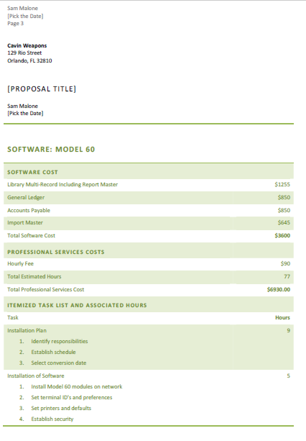

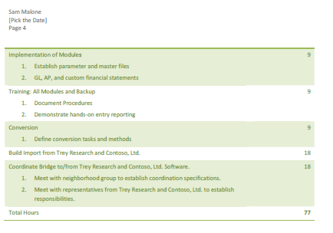

Image-

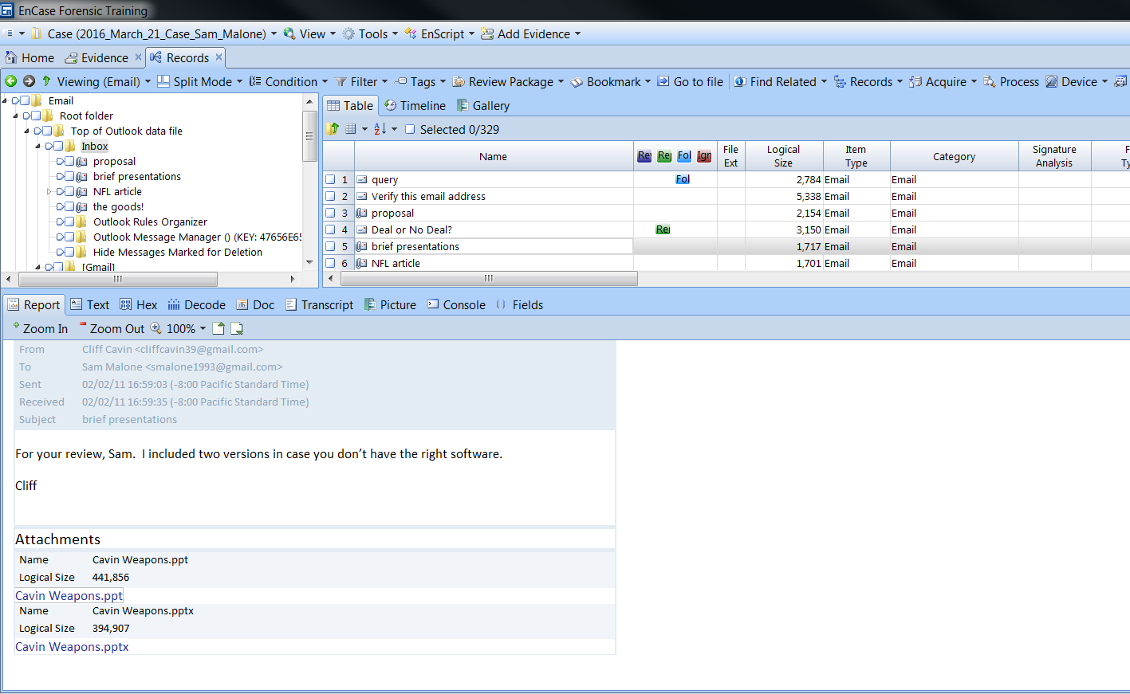

Image-

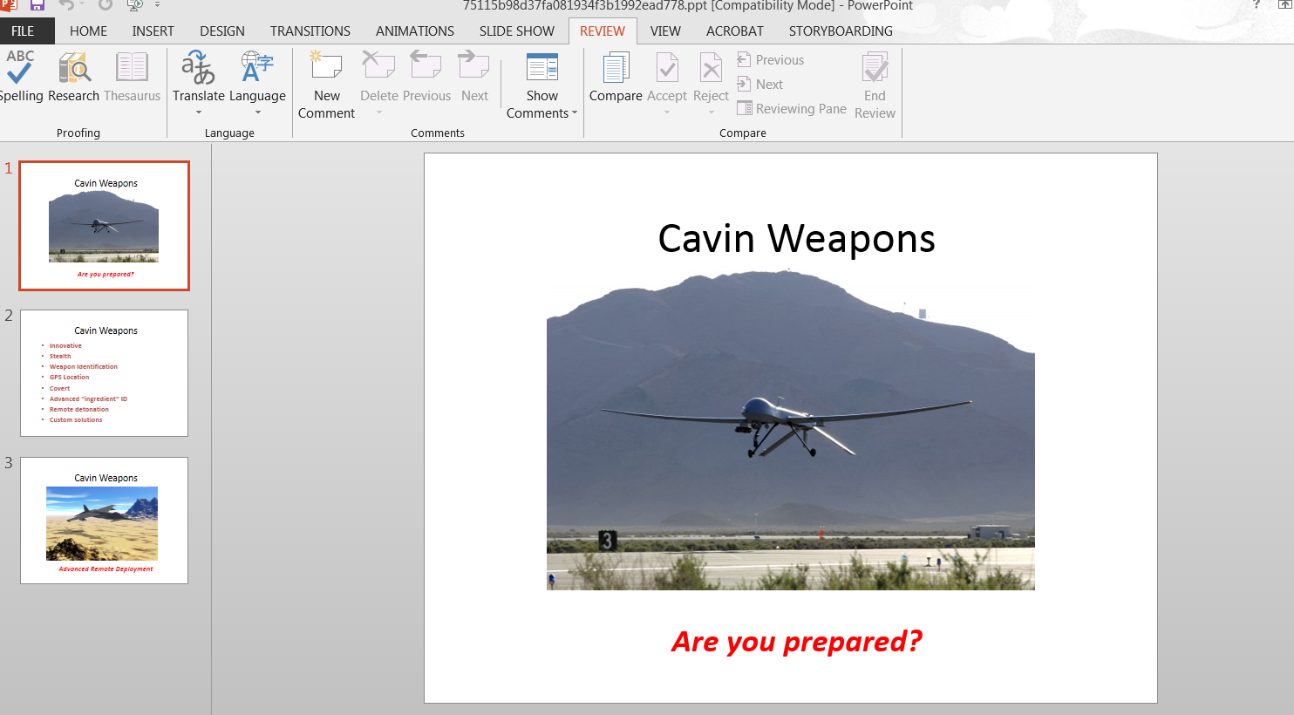

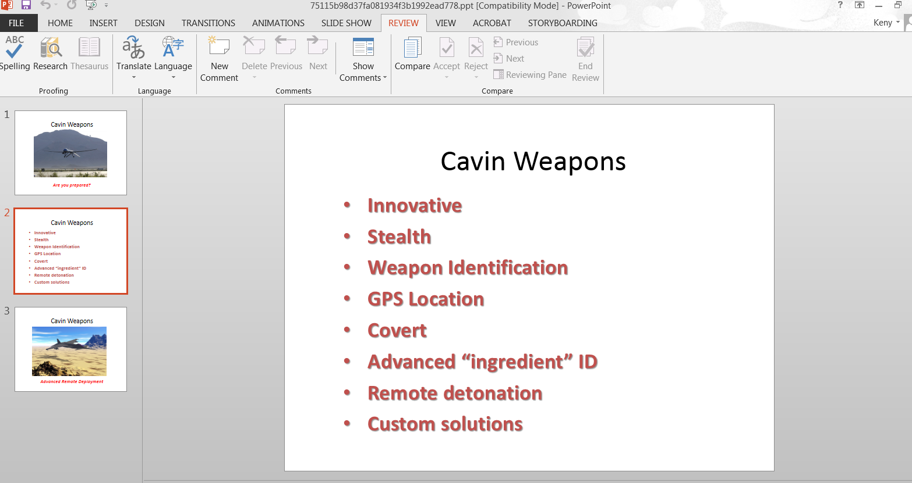

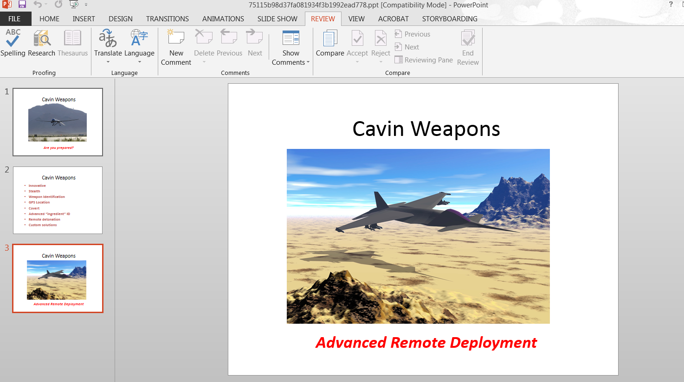

Image-

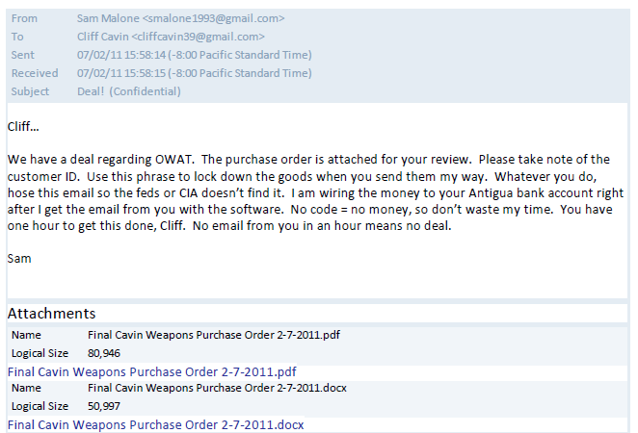

Image-

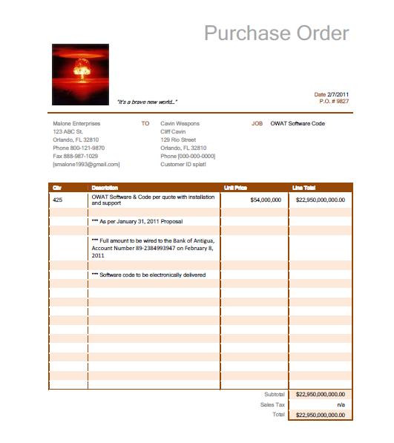

Image-



Image-

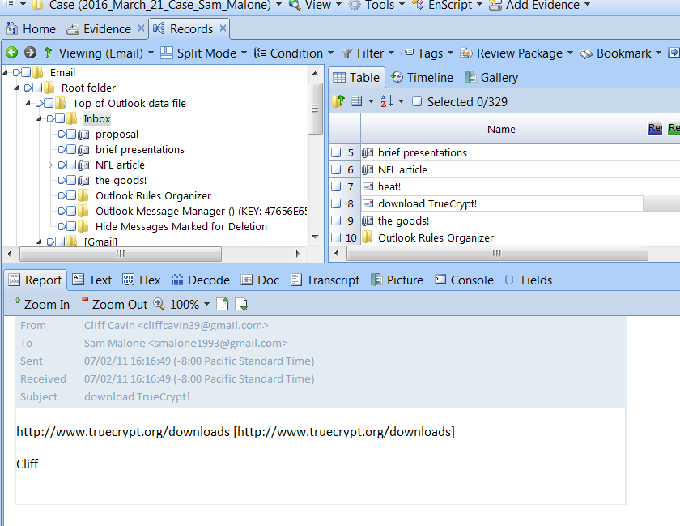

Image-

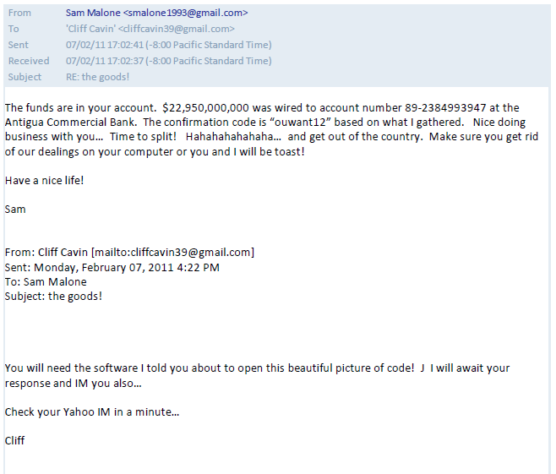

Image-

## Time 4:40pm: Analysis of the E Drive

* Opened the E: drive
* A file in the Finance folder “Malone Enterprises Account Details 2-1-2011.html” contains the account statement which shows dealings with Al Qaeda and transactions in the middle east
* The “My Retirement Software”
* Finances Folder :

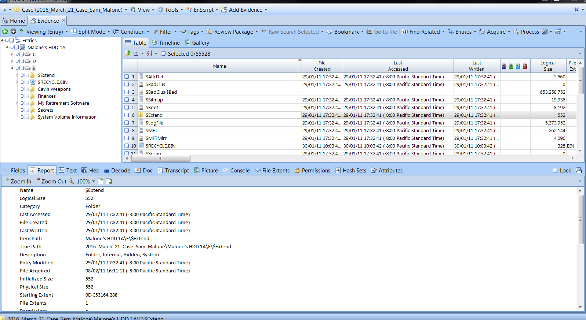

Image- the Folders in the E drive

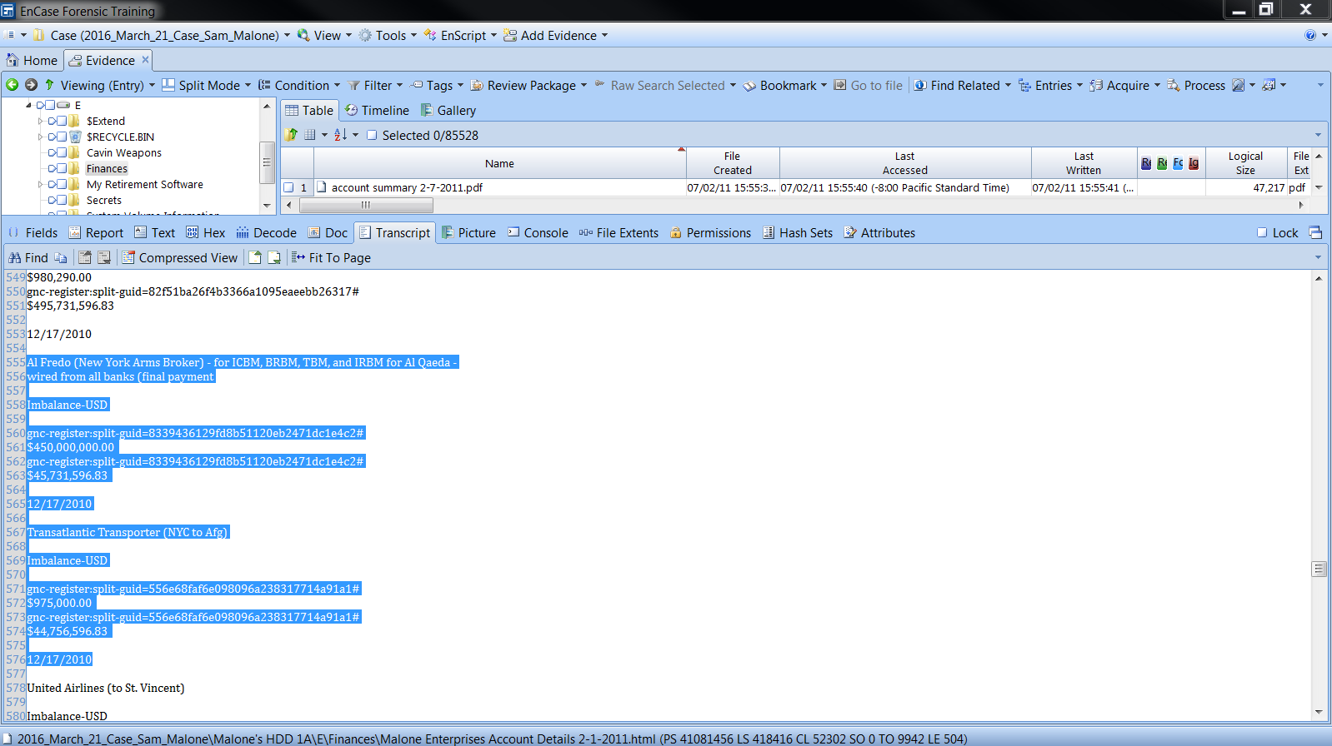

Image- Receiving $450,000,000.00 from Al Qaeda

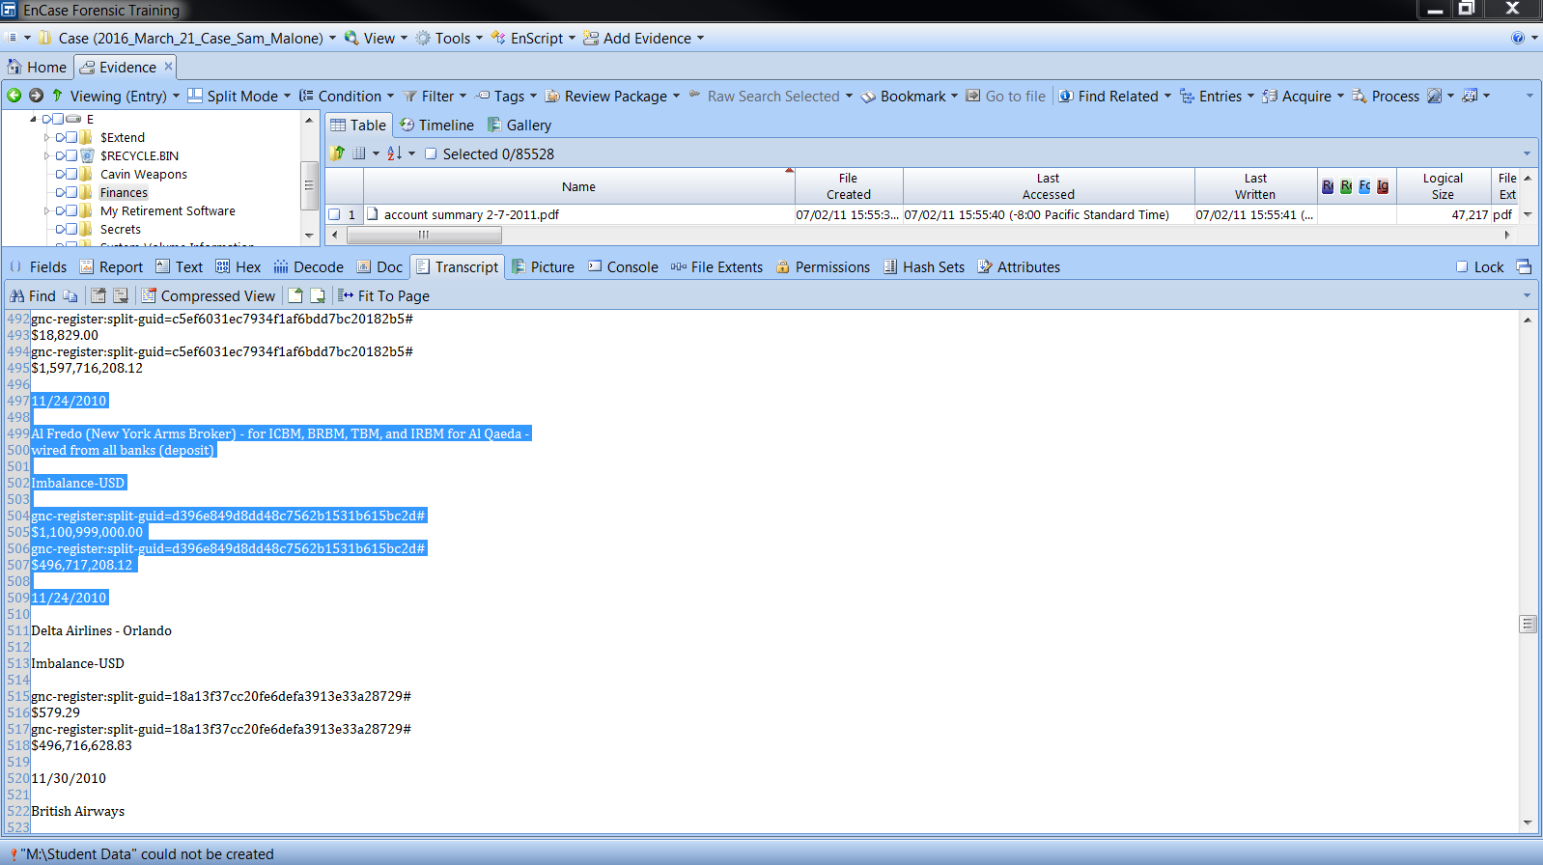

Image- Receiving $1,100,999,000.00 from Al Qaeda

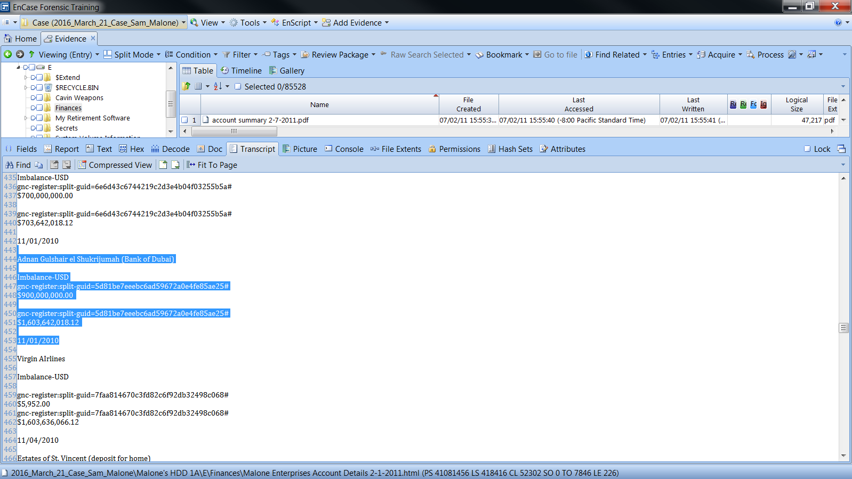

Image- Paid $900,000,000.00 to Adnan Gulshair el Shukrijumah (Bank of Dubai)

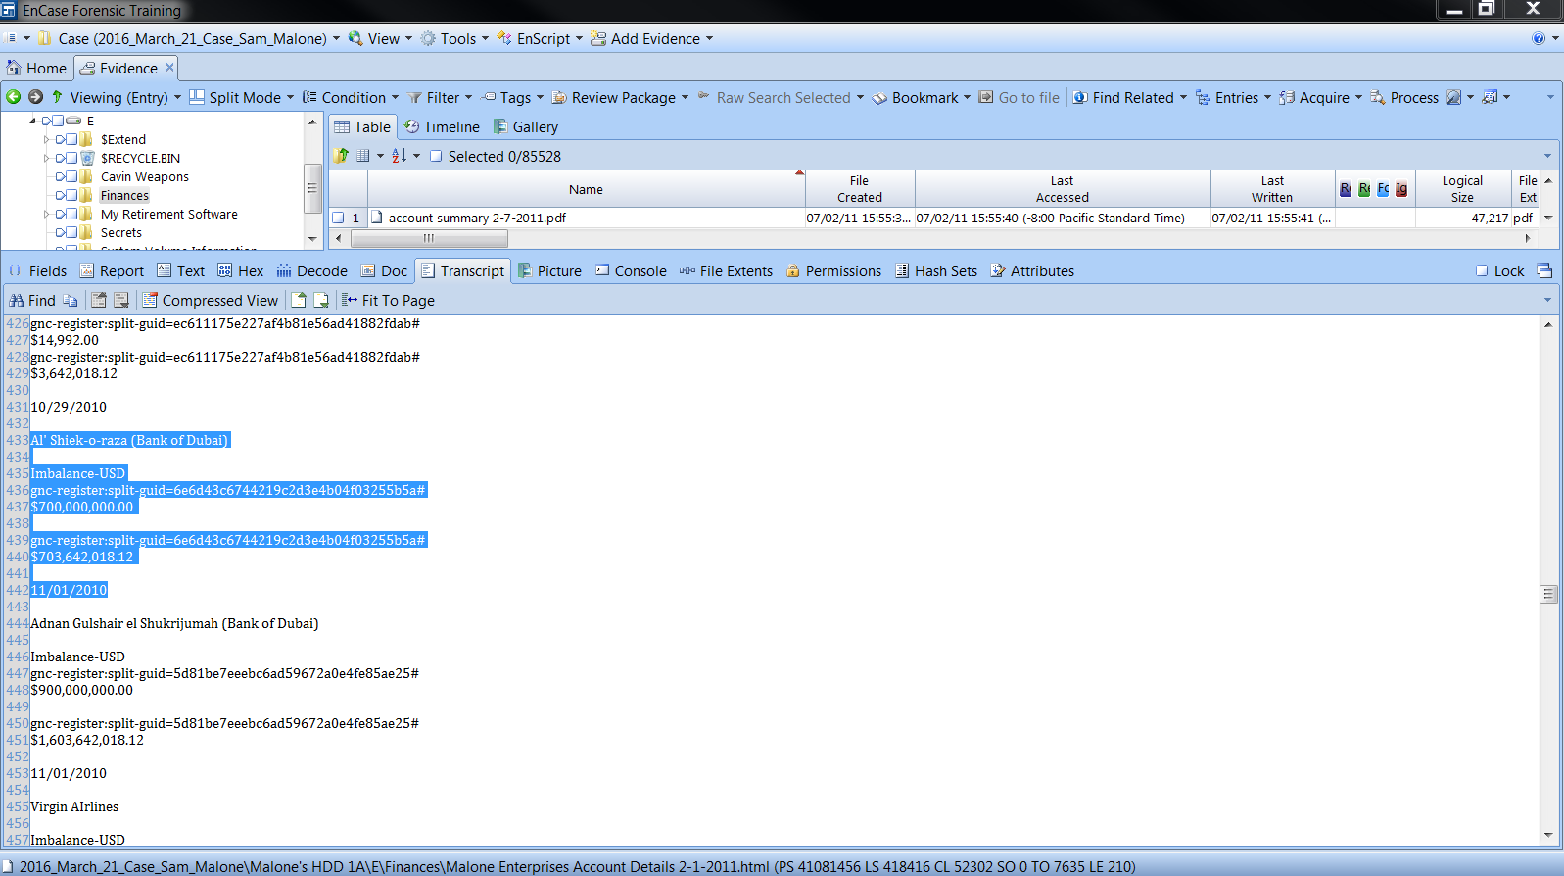

Image- Received $700,000,000.00 from Al’ Shiek-o-raza (Bank of Dubai)

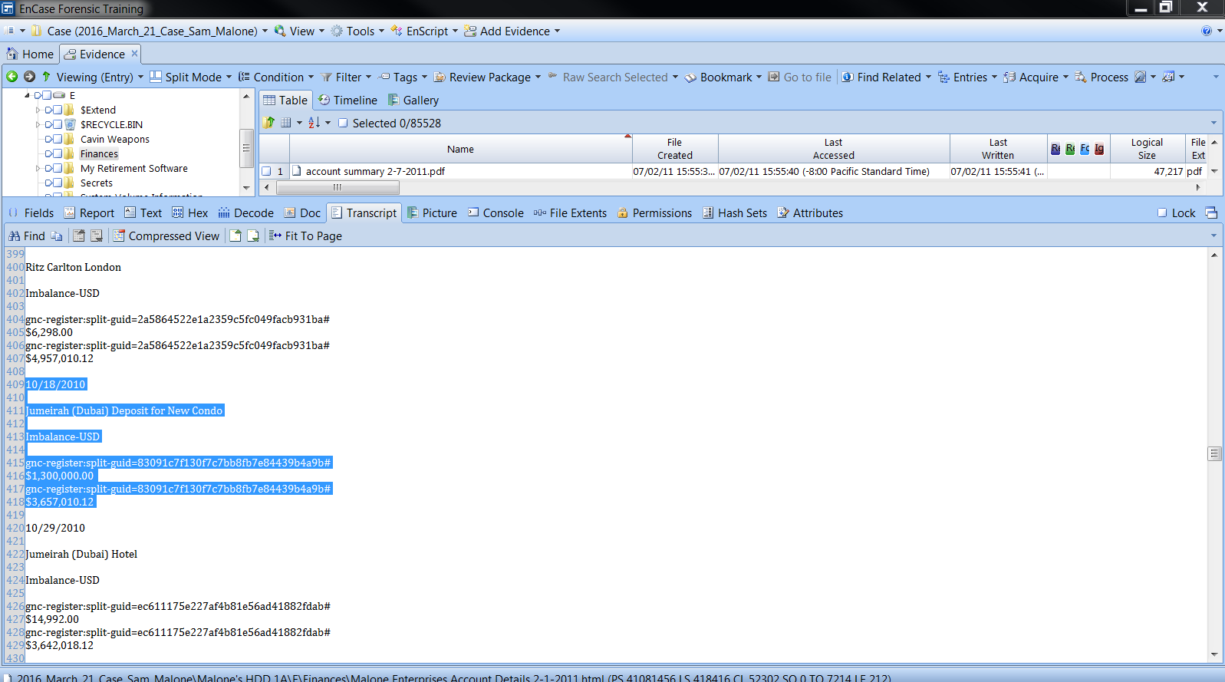

Image- Payment for a new condo $1,300,000.00 received from Jumeirah

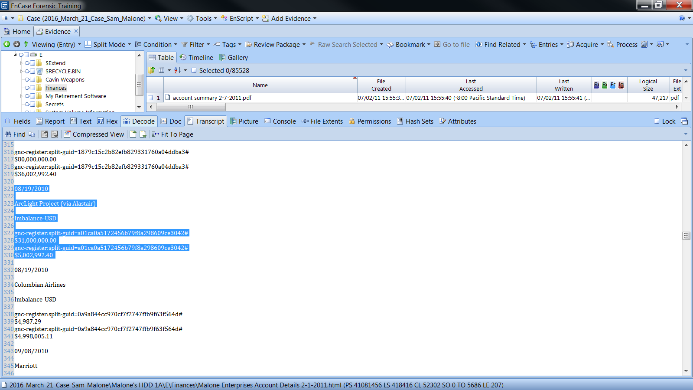

Image- Received $31,000,000.00 for “ArcLight Project (via Alastair)”

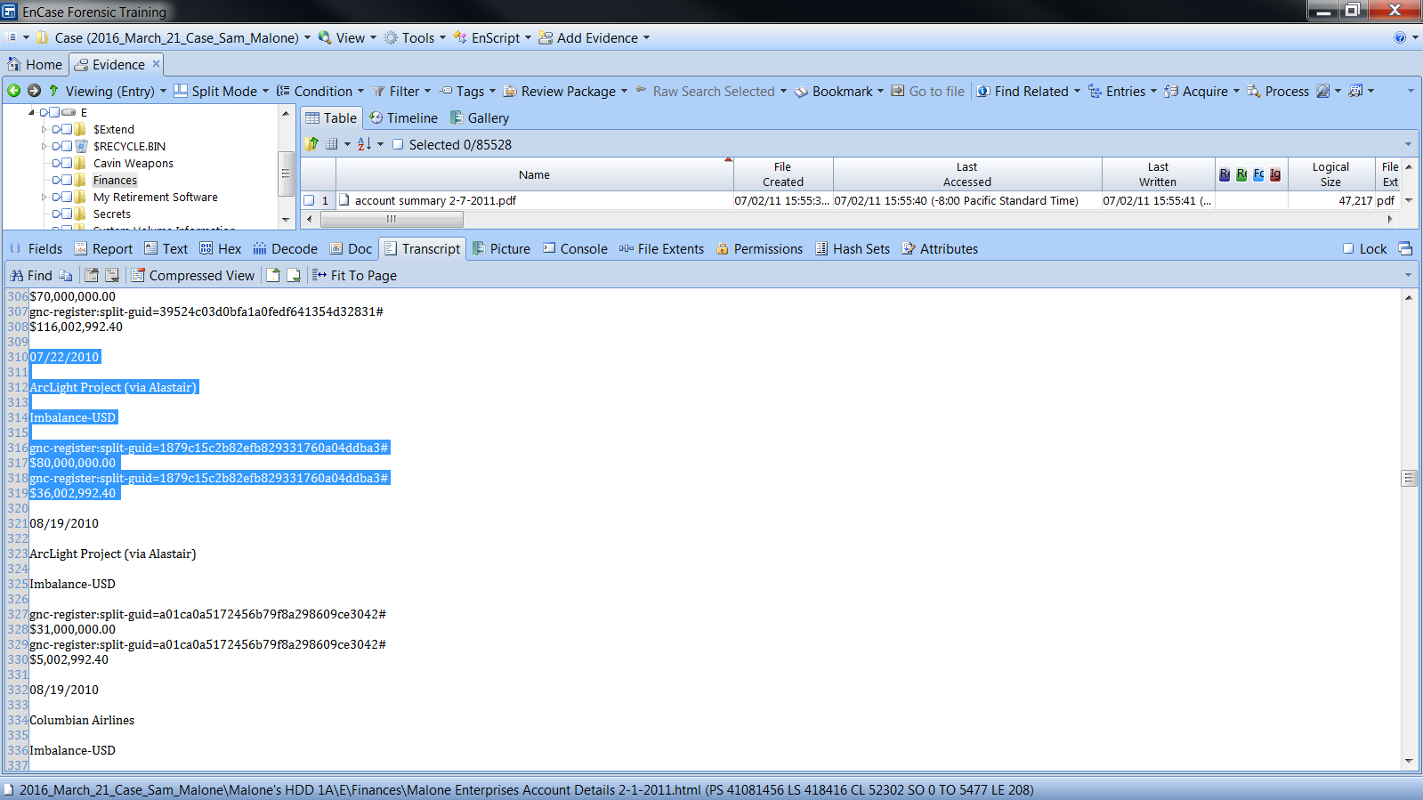

Image- Received $80,000,000.00 for “ArcLight Project (via Alastair)”

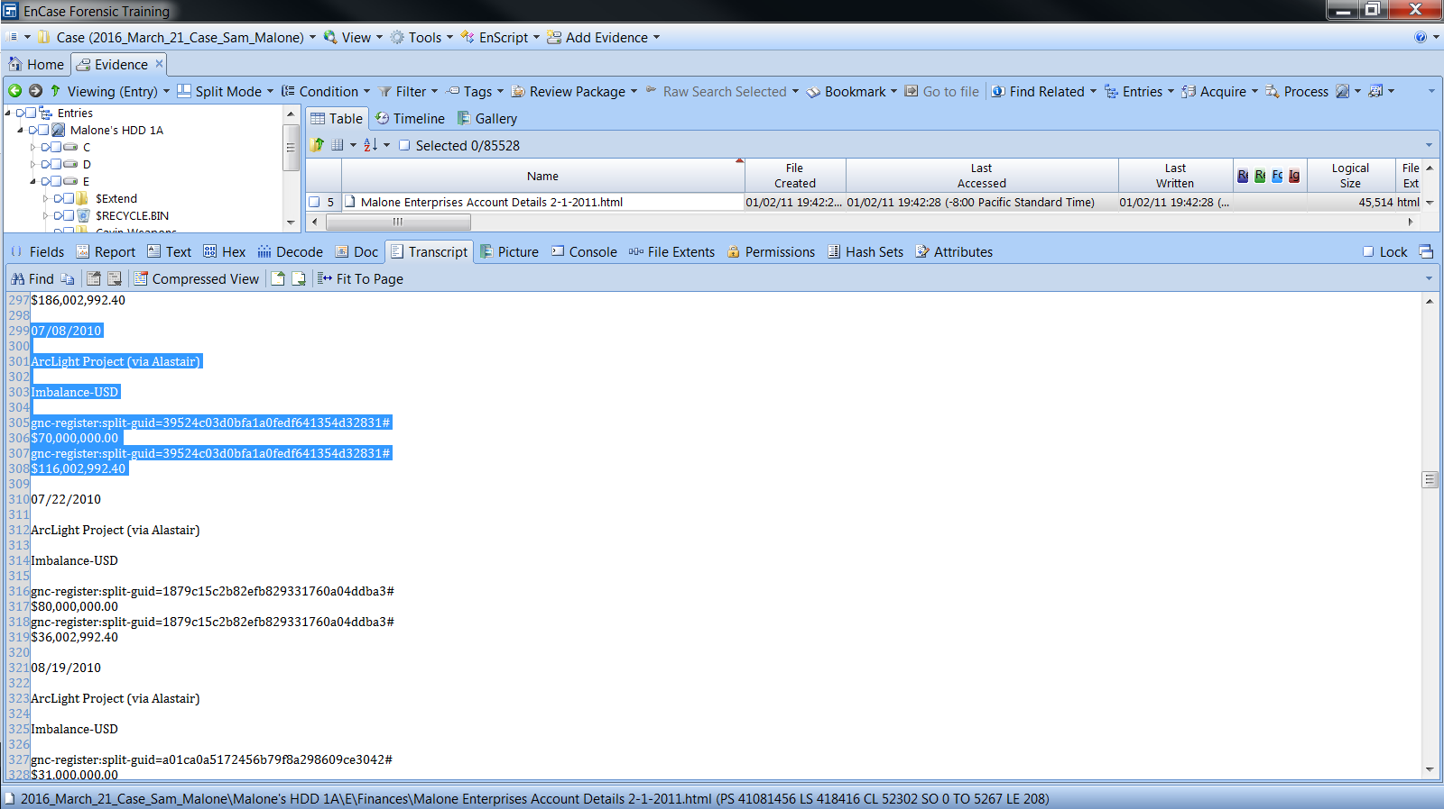

Image- Received $70,000,000.00 for “ArcLight Project (via Alastair)”

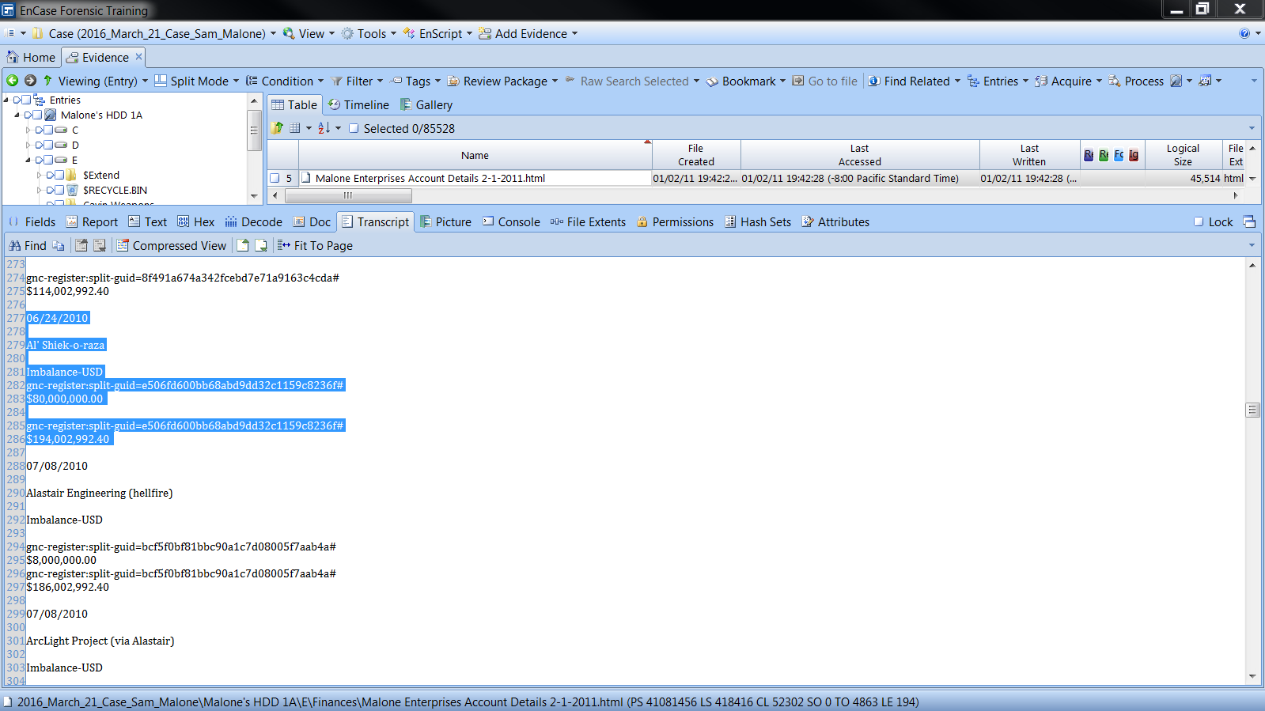

Image- Paid $80,000,000.00 to Al’ Shiek-o-raza

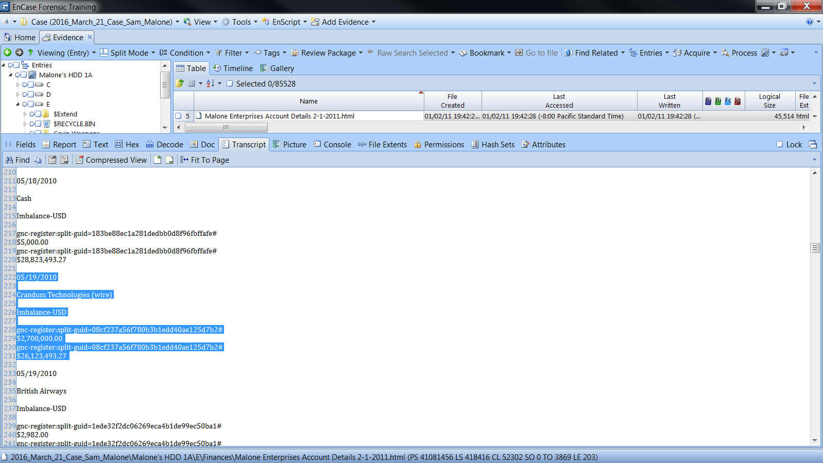

Image- Received $2,700,000.00 from Crandum Technologies

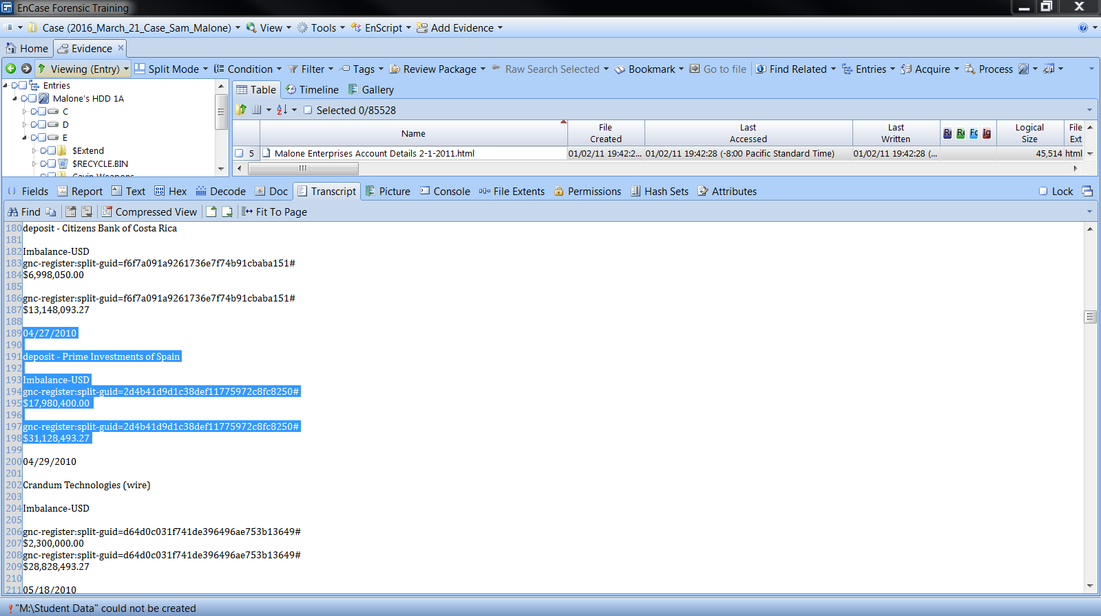

Image- Paid $17,980,400.00 into Prime Investments of Spain

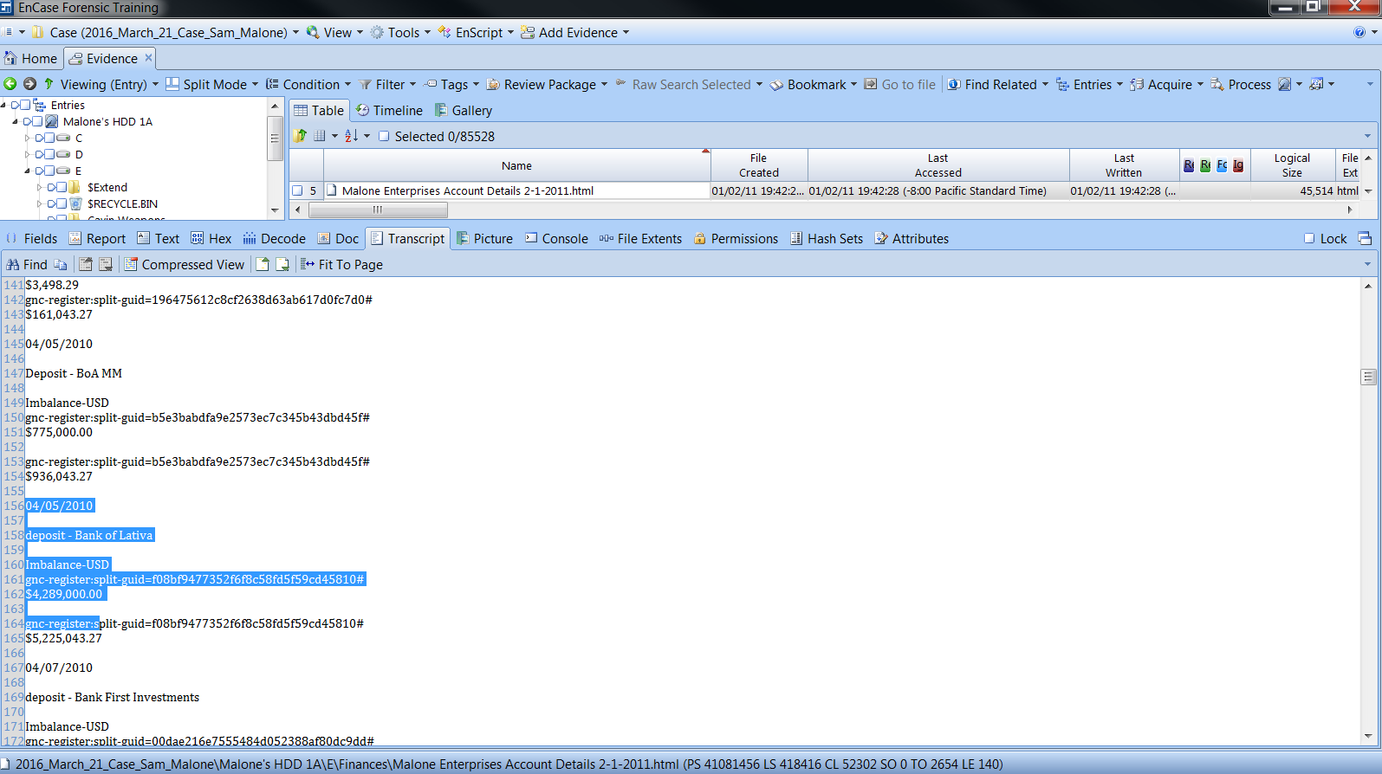

Image- Paid $4,289,000.00 into Bank of Lativa

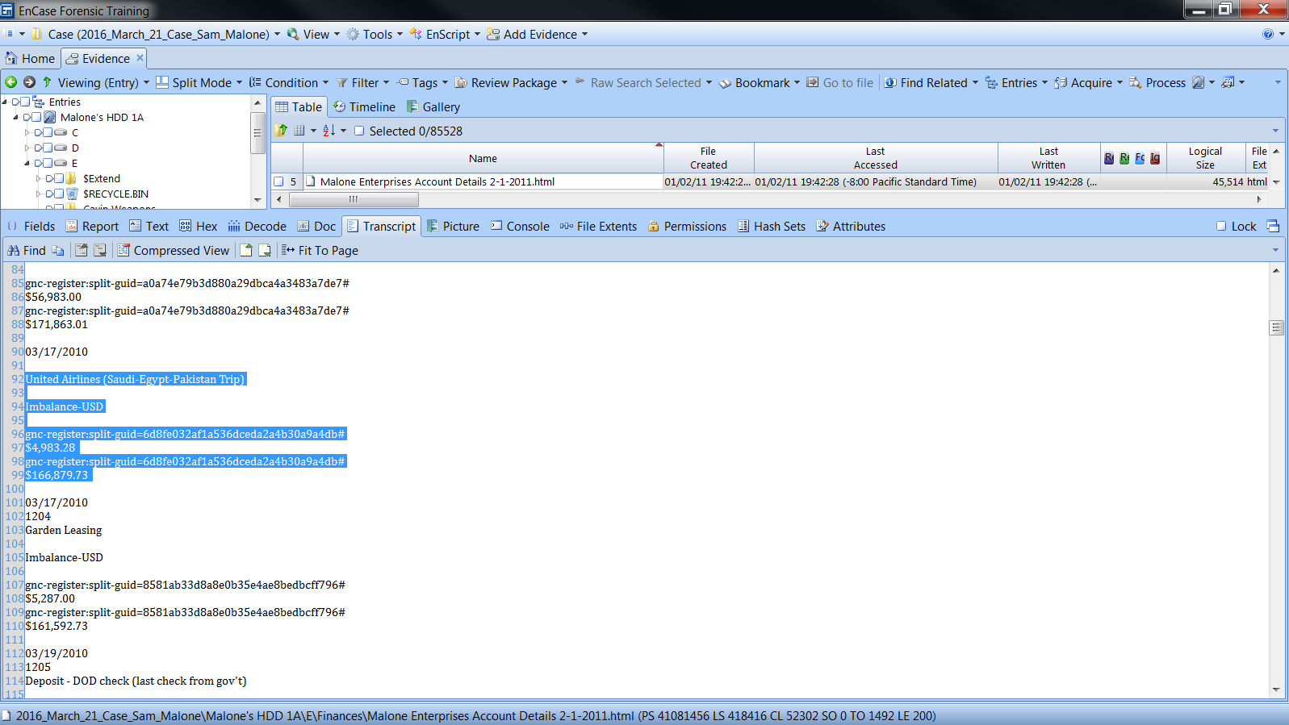

Image- Trip to Saudi-Egypt and Pakistan

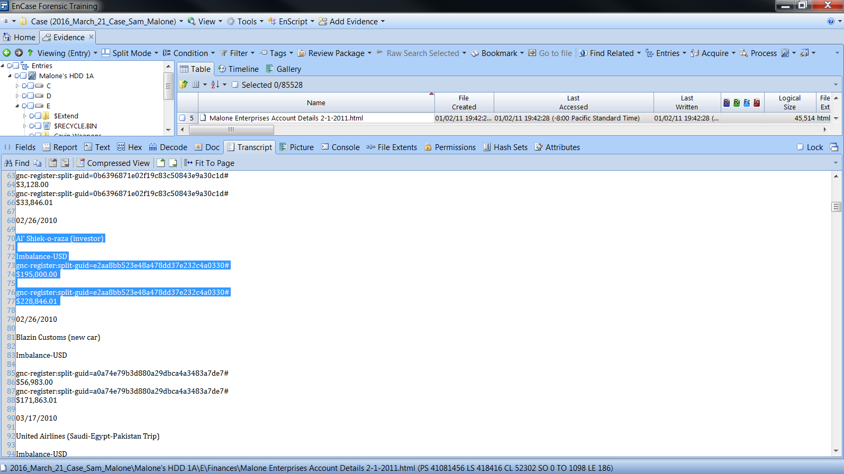

Image- Paid Al’ Shiek-o-raza an investor $195,000.00

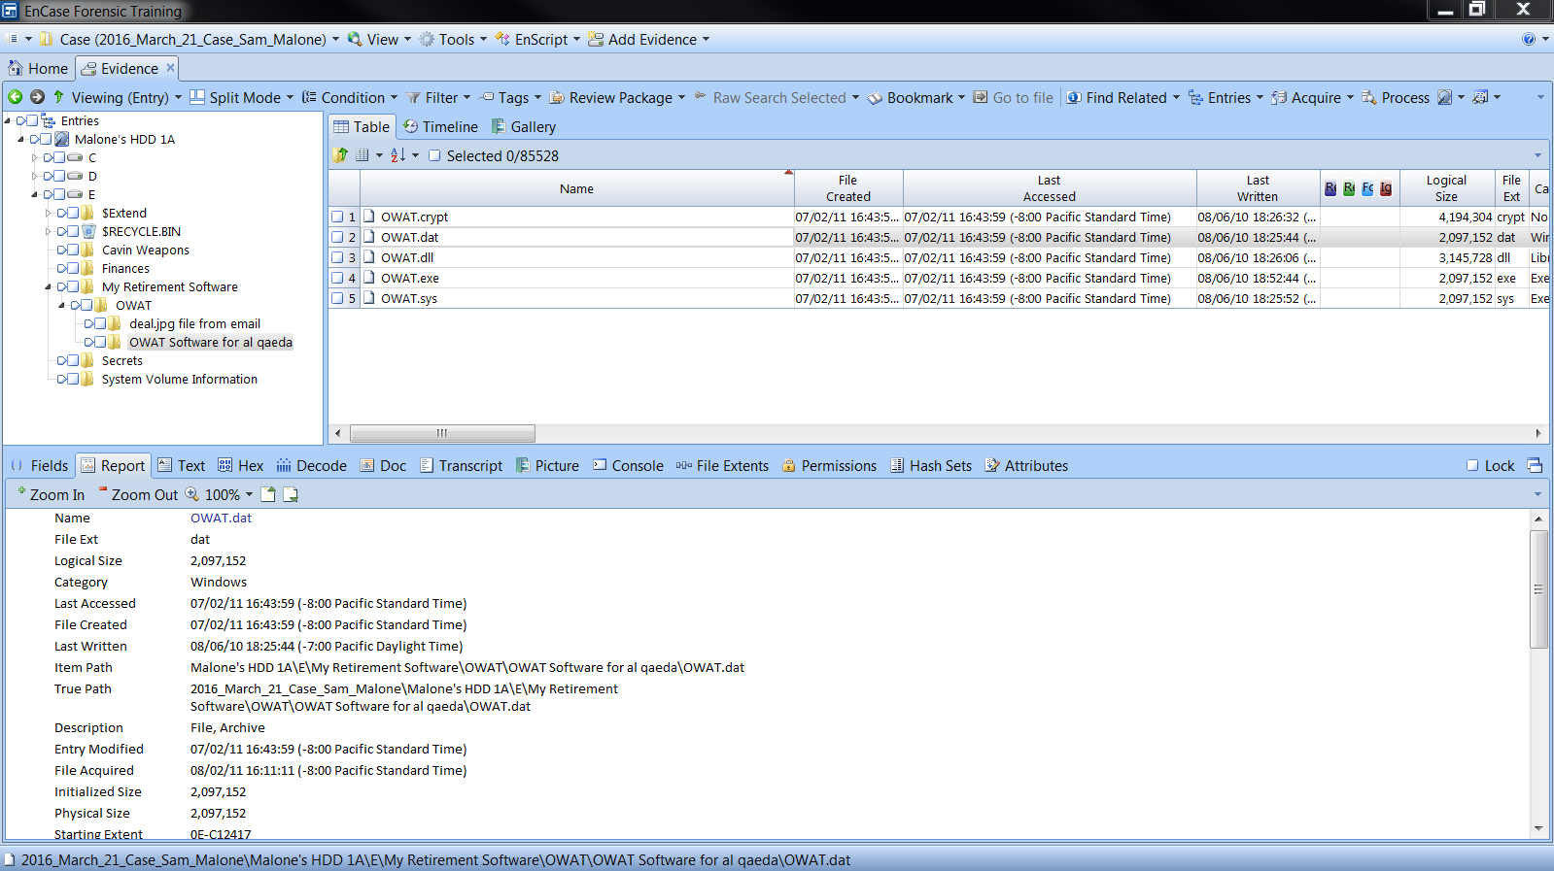

Image- The Al Qaeda Folder in the E drive

## Time 6:30pm: End of investigation